Three County CoC (MA-507) – Quarterly Board Report (September 2025)
This report was compiled for dissemination by September 4th, 2025 prior to the September 18th, 2025 Board Meeting.

Contents
Director Updates 1
Fiscal Updates 5
Compliance Updates 7
Coordinated Entry System Updates: 8
HMIS Lead Updates: 12
Committee Updates 14
Community Success Committee 14
Coordinated Entry Committee 14
Data Evaluation Committee 14
Domestic Violence (DV) Expansion Committee 14
People with Lived Experience (PLE) Action Board 14
Ranking and Evaluation Committee 14
Reimagining Interim Housing Workgroup 14
Landlord Engagement Workgroup 14

Director Updates:
We are happy to report that as of Wednesday 09/03/2025 we have received all Grant Agreements for all non-YHDP CoC funded projects. We are still waiting on the YHDP Grant Agreements for Gandara and DIAL/SELF RRH project, which have a 10/01/2025 start date, as there were some updates that needed to be made to the original applications in ESNAPS, that have now been resolved. Additionally, the YHDP CoC-funded project with MHA, which was reallocated to CAPV Youth Workforce Development for the RRH project, and to Making Opportunities Count for the PSH project have already started their transition period. Both projects will assume complete responsibility for the projects with a 10/01/2025 start date. To date, all Issues and Conditions within ESNAPS have been addressed and resolved.
Update on DV/EMERG Coordinator: Emma Coles was hired into this position starting 07/07/2025.
- General Update:
  - Coordinated Entry Evaluation HUD TA
    - HUD has approved for TAC to provide Technical Assistance to support improvements to the Coordinated Entry (CE) system and advance strategies for addressing the needs of unhoused populations. This request has been prioritized by both our Board and the broader community to ensure a thoughtful and effective approach to system enhancements. This has been listed as a priority for this year, and receiving timely support would be instrumental in maintaining momentum and fostering meaningful progress.
      - Along with this request TAC will provide the CoC with a “Targeted Universalism” Training.
  - Destination Home
    - The CoC has received an impactful amount of funding that will expand our reach and allow us to provide further engagement with People with Lived Experience from our partner Destination Home.
    - Destination Home is a public-private partnership ending homelessness in Silicon Valley.
      - Our goal is to END homelessness in our community and we’re committed to advancing solutions that will deliver true systemic change.
      - Through our collective impact model, we convene and collaborate with stakeholders across our community to advance strategies that address the root causes of homelessness and help ensure that all our neighbors have a stable home. We embrace a data-driven and human approach to our work – advocating for policies, incubating new ideas and programs, and investing in strategies that reduce and prevent homelessness in our community.
      - By working together, we can ensure that homelessness is rare, brief and non-recurring – and create a safer, stronger, more vibrant community for us all.
- Update on scheduled community trainings:
  - Nichele Carver/NJC Consulting
    - Will provide five (5) live Zoom training sessions between July and November 2025 on the following topics:
      - Housing Search (Housing Navigation) - (Completed & Uploaded to TalentLMS)
      - Public Policy and Government in the Homeless Services Sector - (Completed & Uploaded to TalentLMS)
      - Effective Staff Management in Homeless Services - (Scheduled for 09/25/2025)
      - Engaging Individuals Reluctant to Housing or Services - (Scheduled for 10/30/2025)
      - Navigating the New Federal Environment in Homeless Services - (Scheduled for 11/20/2025)
  - Areliz Barbosa/Bay Path University
    - Will provide six (6) live Zoom session between July and December 2025 on the following topic:
      - Trauma-Informed Care and Addressing Mental Health in PSH
    - The same training will be offered each month to ensure partners can attend at a time that works best for them.
      - 2 installments for this training have already taken place.
      - 4 others will be offered on the following dates:
        - 09/11/2025
        - 10/09/2025
        - 11/13/2025
        - 12/11/2025
    - One of the trainings will be recorded and uploaded to the CoC TalentLMS platform.
- 4 County Lunch and Learn Series
  - I have been working with Gerry at the Hampden CoC more closely this year to help coordinate the Lunch and Learn Series. Because there is no CoC competition this summer, we will be offering live Zoom trainings monthly starting in July until December 2025 on the following topics:
    - Talent LMS (Completed & Uploaded to TalentLMS)
    - Employment & Training
      - MASSHIRE Franklin Hampshire (Completed on 07/15/2025)
    - SNAP Benefits
    - SSI
    - Accessing DMH
    - Accessing SUD treatment
    - Compassion Fatigue
    - Non-Discrimination- AGO's Office
    - Worker's Rights- AGO's Office
  - The trainings will be recorded and uploaded to the CoC TalentLMS platform.
- Critical Time Intervention- RRH/TH
  - In partnership with the Hampden CoC, our CoC-funded projects that have RRH/TH funding attended 4-week 8-hour training sessions from June 11th-26th.
    - CTI is an evidence-based practice for quickly connecting vulnerable individuals to services and support in the community. The CoC is offering this training to assist providers to begin making connections early so that program participants will have solid plans for when their time-limited TRRH or TH assistance ends.
    - Update:
      - Training is available on TalentLMS.
- Partner provided:
  - Since May 2025, the CoC has partnered with local organizations to deliver a range of trainings to provider agencies, with a focus on those identified by frontline staff in the CoC Climate Survey. Trainings include the following:
    - Mass Fair Housing- Know Your Rights- Alvin Nguyen, Mass Fair Housing
    - CSEC- Kelly Broadway, Children's Advocacy Center of Franklin County & North Quabbin
    - CLA Info Session- Jen Dieringer, Community Legal Aid
    - CLA Cori and Reentry- Alyssa Golden, Community Legal Aid
    - Understanding Options Counseling- Allen Rodriguez, Stavros CIL
    - Financial Literacy- Amanda Melo Nieves
      - Update:
        - Due to the overwhelming response and attendance for this training, the CoC will enter an MOU with Amanda Melo Nieves as a private contractor to facilitate this training quarterly.
  - Trainings will be recorded for upload to the CoC TalentLMS platform.

Fiscal Updates
HUD FY23 YHDP and FY24 Project Utilizations
General | FY 2024 Contract Utilization
Project | Contract Start | Total Sub-Recipient Award | Point Billed in Contract | Month Billing Processed Through* | Current Utilization (thru last billing)
CoC Projects FY24
HUD A Positive Place | 02/01/25 | $159,976.00 | 50% | July | 39%
HUD Salasin RRH* | 06/01/25 | $361,711.00 | 17% | July | 3%
HUD CHD PSH A & B | 02/01/25 | $845,562.00 | 50% | July | 47%
HUD MOC PSH B | 02/01/25 | $651,082.74 | 50% | July | 49%
HUD LH PSH A | 02/01/25 | $194,479.26 | 50% | July | 39%
HUD DIAL/SELF TH/RRH-PH** | 02/01/25 | $102,834.00 | 35% | July | 15%
HUD Independent Housing Solutions | 02/01/25 | $165,186.00 | 50% | July | 61%
HUD Louison House TH | 02/01/25 | $141,241.00 | 50% | July | 51%
HUD Louison House Northern Berkshire PSH | 02/01/25 | $206,631.00 | 50% | July | 48%
HUD Louison House Bracewell | 02/01/25 | $124,960.00 | 50% | July | 43%
HUD Village Center Apartments | 02/01/25 | $79,853.00 | 42% | June | 29%
YHDP Projects FY23
HUD YHDP DIAL/SELF RRH Franklin*** | 10/01/24 | $81,164.00 | 71% | July | 38%
HUD YHDP Gandara SHINE TH-RRH | 10/01/24 | $451,557.00 | 72% | July | 73%
HUD YHDP MHA PSH **** | 10/01/24 | $200,508.00 | 75% | June | 66%
HUD YHDP MHA Youth Nav/RRH ***** | 10/01/24 | $220,632.00 | 75% | June | 57%
YHDP Projects FY24
HUD YHDP DIAL/SELF RRH Franklin | 1/1/2026 | $86,272.00 | 0% |  | 0%
HUD YHDP Gandara SHINE TH-RRH | 10/01/25 | $472,053.00 | 0% |  | 0%
HUD MYHP MOC Youth Housing | 10/01/25 | $201,048.00 | 0% |  | 0%
HUD CAPV Youth Nav/RRH | 10/01/25 | $220,992.00 | 0% |  | 0%

*FY24 HUD Salasin their contract was executed for start date 6/1/2025. Their contract ends 5/31/2025.
**FY24 HUD DIAL/SELF TH PH-RRH Joint has requested a no cost extension until June 30, 2026. with a reduction in units. The request has been approved by HUD and we are still waiting on SNAPS’ approval due to the reduction in units.
*** FY23 HUD YHDP DIAL/SELF RRH has requested a no cost extension until December 31,2025 and HUD has approved the extension.
****FY23 HUD YHDP MHA PSH was forecasted to have excess funding at the end of the project. The request to HUD was approved to transfer funding from MHA to MOC for a portion of the funding. FY23 YHDP MHA PSH is still fulfilling its obligations under the contract.
***** FY23 HUD YHDP MHA Youth Nav/RRH was forecasted to have excess funding at the end of the project. A request has been submitted and approved by HUD to transfer the excess funds to CAPV Youth Workforce & Development. FY23 YHDP MHA RRH is still fulfilling its obligations under the contract.
We are working with FY23 YHDP Projects to prepare for closing out in September and December 2025, in hopes of reducing any unused funding.
We have received a small grant from Destination Home for $26,000.00, to utilize PLE support and can be utilized toward our match commitment to HUD.
We have been working with Rebecca Himlin, Director of Planning and Resource Development and Jess Thompson, Associate Director of Community Engagement in the hopes of finding some additional grants, and as always we are still working on our match requirements. We are also working with our TA Contractor TAC, as they may be able to assist us in finding some RRH grants.
Office hours are still the 3rd Wednesday of the month from 10:00-11:00.

Compliance Updates
Subrecipient Monitoring
Subrecipient Monitoring is wrapping up, and initial score results and monitoring letters will be issued in the upcoming week.
Strengths of our projects included verification of homelessness and chronic homelessness, Housing Standard inspections, and services provided to participants of projects.

Monthly Office Hours will resume in October
- Office hours were temporarily put on hold to better assess TA needs through site monitoring of participant files. Monthly Office Hours will return soon with the following topics:
  - Rent Reasonableness: Developing a procedure and documentation
  - Housing Standards Inspections
  - Documenting Chronic Homelessness and Disability for PSH
    - While PSH projects did well in Subrecipient monitoring, some of the minor revisions to forms and documentation standards are being updated to improve how referring partners in Coordinated Entry assist with documenting eligibility. These changes will be first introduced to Subrecipients for feedback/revision before they are shared with referring partners.

Coordinated Entry System Updates:

- We are excited to announce that a few new projects have accepted their first referrals!
- Our new DV-specific Rapid Rehousing project with the Salasin Project has accepted its first 2 referrals
- Louison House’s Bracewell Project that provides PSH for Youth has accepted its first 4 referrals
- We have successfully referred 9 individuals to Hearthway’s PSH Project in Pittsfield

- Since June 2025, the Three County CoC has onboarded 25 new Coordinated Entry Assessors to be trained to either complete vulnerability assessments and/or attend Case Conferencing Meetings.
- The Coordinated Entry Specialist began hosting monthly live Coordinated Entry Process and Assessment Tool training available for new Coordinated Entry Assessors and those who would like to review the process.

- Since our last report in June 2025 the Coordinated Entry system has seen the following enrollments and/or placements into CoC-funded housing or with our partners:
- Transitional Housing (TH): 9 total
- Louison House TH: 9
- Rapid Rehousing (RRH): 12 total
  - Salasin Project’s new RRH for DV Survivors: 2
  - CSO’s RRH: 8
  - DIAL/SELF’s YHDP RRH: 2
- Permanent Supportive Housing (PSH): 19 total
- Hearthway PSH Partnership: 9 referrals made, applications being processed
- Louison House Bracewell Youth PSH: 4
- Louison House Pittsfield PSH: 2
- Making Opportunity Count (MOC): 3
- Independent Housing Solutions (IHS): 1

- The Three County CoC’s Existing Projects are:
  - A Positive Place (APP) (Cooley Dickinson)
  - Adult Independent Living (Construct)
  - DIAL/SELF RRH Franklin
  - DIAL/SELF TH/RRH-PH
  - Gandara SHINE TH/RRH
  - Independent Housing Solutions (IHS) PSH
  - Louison House Bracewell Youth PSH
  - Louison House Pittsfield PSH
  - Louison House Northern Berkshire PSH
  - Louison House TH
  - Making Opportunity Count (MOC) PSH
  - Paradise Ponds (Way Finders)
  - Salasin Project RRH
  - Village Center Apartments (Hilltown)
  - MHA (Mental Health Association) PSH
- Program will be taken over by Making Opportunity Count (MOC) on October 1st, 2025
  - MHA and MOC have met to start the transition process.
  - Contract amendments for existing funding from MHA have been transitioned to MOC to start this process.
  - MHA (Mental Health Association) Youth Navigation/RRH
- Program will be taken over by Community Action’s Youth & Workforce Development Programs (Y&WFD) on October 1st, 2025
  - The CoC and YWD have met to start the transition process.
  - An MOU has been signed between both MHA and YWD to start the transition process.

- MOU Partnership Updates
  - Hearthway
    - Permanent Supportive Housing (PSH)
      - The Three County CoC has a partnership with Hearthway for them to accept referrals through the Coordinated Entry System for their newly constructed PSH units. There are 9 PSH units located at First Street and 28 PSH Units located at West Housatonic Street in Pittsfield.
      - Tenant selection has been completed through the Coordinated Entry prioritization process for all 9 units located at First Street. CE referrals have been completed, and service providers are currently submitting applications to Hearthway for the MRVP vouchers associated with each of the units. As applications are approved, individuals will begin moving into the units.
      - We will soon move forward with the tenant selection process for the 28 West Housatonic Units, in anticipation of the December 1st opening date. Those that were not selected for the First Street Units will be discussed and prioritized accordingly.
  - CSO
    - Rapid Rehousing (RRH)
      - The Three County CoC has a partnership with CSO to take referrals from Coordinated Entry for their Rapid Rehousing (RRH) Assistance. The assistance can be used for either unit move-in costs, including first and last month's rent and security deposit. In some cases, the funds can be used to settle past-due arrears or to obtain new copies of an individual’s documents, such as IDs or Birth Certificates.
    - Permanent Supportive Housing (PSH)
      - Referrals will come from the CE system in the following manner:
        - Referral by the CoC from the By Names list, using the priorities and preferences established in
        - the TSP, to CSO
        - Screening by CSO
        - Application for HRA Section 8 subsidy (with assistance from CSO case manager)
        - Once approved for Section 8, lease up and occupancy of the unit can begin
      - 36 units
      - Update:
        - Project is still projected to be ready for occupancy by end of May.
        - Initial coordination will start in December.
        - Since the process is going to take a bit to get everyone ready to move in, potential referrals will start to be identified in case conferencing in late March.
        - Referrals from the CE/BNL will start to happen in early to mid-April.
        - Participants will need to be completing applications, providing their essential documents such as picture ID, SS card, birth certificate, income, bank statements, etc. and attend a briefing to learn about the program.
        - CSO will assist to support document gathering specifically someone staying with CSO.
- Emergency Housing Voucher (EHV)
  - The CoC received updated information that the EHV vouchers that were set to sunset in 2030, are now set to sunset in December of 2026.
  - # Referred: 86 (there was a 6 voucher increase from EOHLC in March 2024)
  - # Housed Since November 2021: 85 (Through for RAAs: Hearthway/Way Finders/NHA/FCRHA)
  - # of vouchers recaptured: 6 (Through EOHLC) (0 Directly from HUD)
  - Final Update:
    - Final #s for Franklin County Regional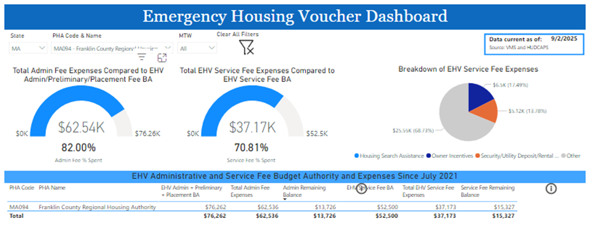
    - Final #s for Northampton Housing Authority
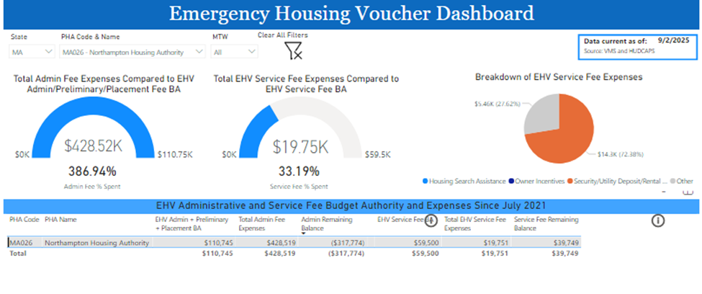
    - Final #s for EOHLC
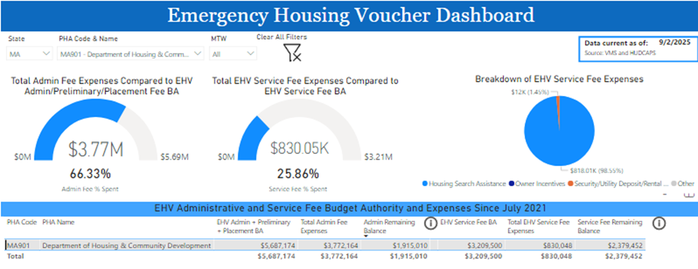
- DV Moving to Work Vouchers (DV MTW)
  - # Referred: 23
  - # Issued/In Housing Search: 2
  - # Housed Since July 2024: 21
  - # In application process: 0

HMIS Lead Updates:
Executive Office of Health and Human Services (EOHHS) Homeless Youth Services (HYS) data entry and reporting is moving to HMIS per a new state requirement. This move has been expected for a few years and is a welcome change- previously this data was not included in many of our federal reports because it wasn’t in HMIS so we’ll have a much better sense of youth and young adult homelessness, both in those federal reports and in our own data analysis. It will also allow us to de-duplicate client records to get a more accurate number of youth and young adults experiencing homelessness or housing instability.
The process to move from the current system- the Green River Open Path Warehouse- to our CAPV Clarity HMIS involves creating the projects and data collection screens, creating reports, training staff on how to collect data, and migrating data from the warehouse to the HMIS. The project and data entry screen buildout is nearly complete but continual updates and guidance from the state have caused the process to change a few times throughout the setup. Staff training has begun but training was primarily focused on an earlier setup and needs to be continual as staff get used to the new process. Data from the warehouse is currently being migrated to the HMIS with a focus on moving current open client records and client history from 1/1/2024 and on to start with. CAPV is currently waiting on feedback from the state that will clarify the need for another change to the data collection setup and hopefully will finalize the project setup and guidance for HYS providers. Agencies like Dial/Self, Louison House, and Upside413 provide street outreach, homelessness prevention, emergency shelter, flex funds, move in assistance, access to FYI vouchers, a college pilot program, case management, and additional services often as needed through these programs.

The 2025 January Point in Time Count and Housing Inventory Chart was submitted to HUD on June 13th, 2025. There were 867 people identified who were experiencing homelessness in Berkshire, Franklin, and Hampshire Counties on January 29th, 2025. This is 94 fewer people than were identified as experiencing homelessness in January of 2024, primarily due to a decrease in family homelessness. In 2024 there were 507 people in families experiencing homelessness and in 2025 this number was down to 290 people in families in shelter. On the other hand, the number of individuals experiencing homelessness continues to increase, from 454 people in 2024 to 577 people in 2025.

Additionally, a Summer Point in Time Count took place on July 20th, 2025. Results from the summer count are still being compiled and cleaned and will be shared with the board when complete.
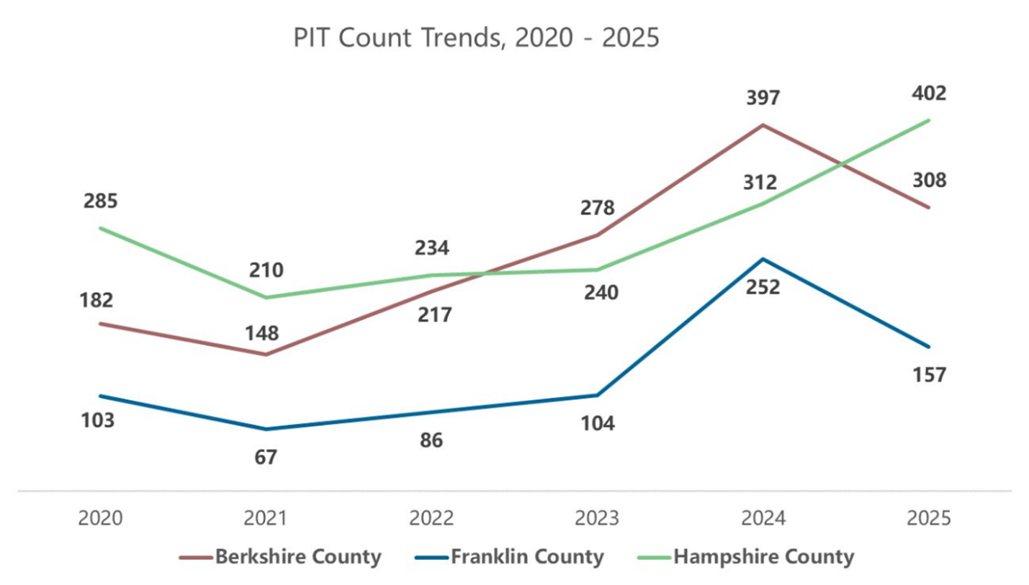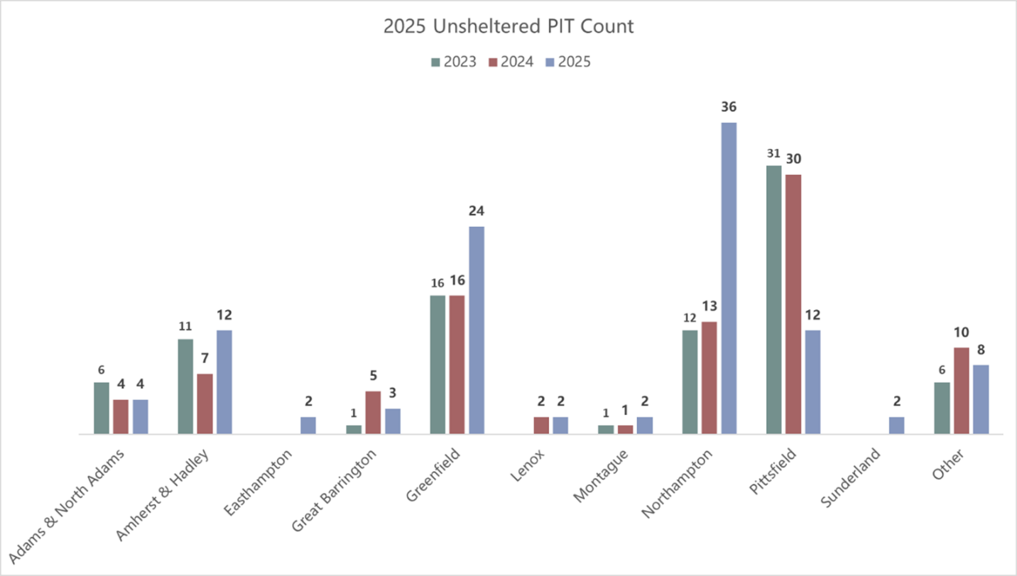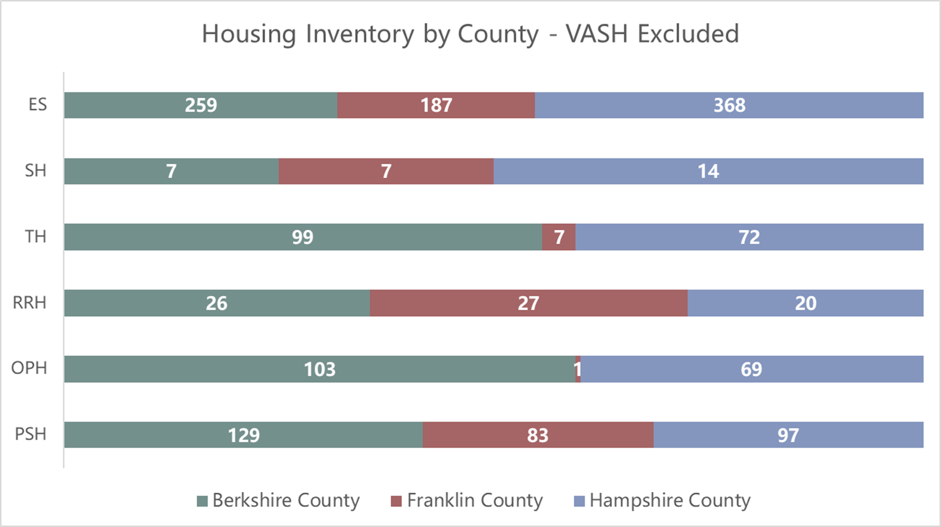
ES: Emergency Shelter
SH: Safe Haven
TH: Transitional Housing
RRH: Rapid Re-Housing
OPH: Other Permanent Housing
PSH: Permanent Supportive Housing

Committee Updates
All CoC committees and workgroups are looking for co-chairs and people with lived experience of homelessness to lend their voices to the work of ending homelessness in the Three County area. The CoC staff have developed a policy that provides compensation to people with lived experience for their time and perspectives. Please note that the CoC Governance Charter states that “All Funded Projects must have representatives who participate on Committees. All Committees must include at least one Board member who is responsible for communicating committee activities to the Board.”

Community Success Committee
The Community Success Committee last met on August 20th. At this meeting, the Committee discussed the revisions to HUD’s FY24 data standards that will be implemented in FY26; specifically, the retiring of gender and sexual orientation data elements. There is still interest in collecting this data but further discussion among the CoC, especially the Board and funded projects, is needed. The Committee then reviewed the training suggestions from the spring Climate Survey, assessing which requested trainings have been provided, which are scheduled for later this year, and which would be new. Finally, we talked briefly about the anti-camping ordinance in Pittsfield and the overall shift towards criminalization, and how to more effectively promote the message that “housing solves homelessness”.

The next meeting is scheduled for September 17th from 11:00am-12:30pm.

Coordinated Entry Committee

The Three County CoC has been approved by HUD to receive technical assistance this year from a provider with the Technical Assistance Collaborative (TAC) to reevaluate the Coordinated Entry System. The Coordinated Entry Committee has been preparing to work with our TAC Provider by having collaborative discussions on what parts of the coordinated entry system they would like to be evaluated and improved in order to best serve our participants. In these discussions, the previous evaluation completed in 2023 was reviewed, and new ideas and goals for the Coordinated Entry Assessment and overall coordinated entry process were documented to be shared with the TAC Provider. The CE Committee’s next step is to meet with the TAC provider to discuss the evaluation process.
The next meeting is scheduled for September 23rd from 11:00am – 12:30pm.

Data Evaluation Committee
The Data Evaluation Committee has been on pause as the gaps analysis focus groups are planned and organized and the HMIS Lead works to meet the EOHHS transition deadline. The committee created and sent out a new survey to inform this year’s gaps analysis to make recommendations for needed resources within Hampshire, Franklin, and Berkshire Counties. The survey can be found here- https://form.jotform.com/251033500806141
Responses may still be submitted and will be reviewed by the Committee membership along with the results of the Point in Time (PIT) Count and Housing Inventory Chart (HIC).
In addition to the survey and PIT/HIC data, the Committee’s intention is to hold at least 1 (but ideally 3) focus group or listening session where people experiencing homelessness are compensated for participation in a more open-ended discussion around needed resources in the region.
The Data Evaluation Committee has plans to assist with the implementation of the Outreach and Inventory Modules of the Clarity HMIS System after the Gaps Analysis Report is released.

The next meeting is scheduled for September 8th from 11:30am – 1:00pm.

Domestic Violence (DV) Expansion Committee
The DV Expansion Committee last met on August 14th. In this meeting, the Committee discussed both the benefits and safety concerns of creating physical resource cards to distribute. They also reviewed the Warm Hand Off form created by the CE Specialist, and weighed in on the idea of creating a simple DV CE Coding Guide.
In addition to the Committee meeting, CoC staff have met twice(?) with the consultants that are developing a DV 201 training. This training is still being developed, but some topics that will be covered are resources for survivors in Western MA, survivor involvement with law enforcement, and coercive control.
The consultants will also be holding two focus groups for survivors who have interacted with housing services, scheduled for September 16th and 17th. As of September 4th, # have signed up. Anonymous responses from these focus groups will also be included in the DV 201 training.
The next meeting is scheduled for September 9th from 2:00-3:30pm.

People with Lived Experience (PLE) Action Board
The PLE Action Board last met on August 8th. During the June meeting the group was asked to provide feedback to the Housing Consumer Education Center on various questions, such as, “What’s one thing HCEC staff could do when someone first walks in to immediately build trust?”, “What language or tone of voice do you feel works best when engaging with someone who is unhoused or in distress?”, “How can we avoid making assumptions or being unintentionally stigmatizing?”, and “What should we be mindful of to avoid re-traumatizing people?”. The group continued planning for the PLE Summer Cooling Kits Drive, they identified collection dates and sites, and dates to give out the kits. The group also worked on identifying items that they know will be useful for our unhoused neighbors. Summer PIT final planning also happened with Natalie. During the July meeting, Emma introduced herself in her new role, the group was made aware of a Focus Group opportunity w/the CoC that will focus on GAPS analysis. The group was made aware that after certain members took part in a focus group hosted by NCH, they were invited to submit a proposal to be presenters at the NCH Leadership Conference in November. During the August meeting the group reviewed and started to update the PLE Action Plan. The second round of LETA students have started to finish their training and are hopeful of moving forward by working with the National Coalition for the Homeless more directly. Board members that have not completed the LETA training will have the opportunity in November to take part in the Third round of students.

The next meeting is scheduled for September 11th.

Ranking and Evaluation Committee
The Ranking and Evaluation Committee last met on September 4th at 10:30am.

During the February meeting the committee focused on Subrecipient Monitoring and Evaluation with a discussion on whether to implement subrecipient monitoring in 2025 and how it will be carried out in the coming months. The group provided past monitoring reflections and feedback was gathered on last year's monitoring process, including a questionnaire sent to subrecipients and an Excel sheet used by COC staff for scoring.

The next meeting

Reimagining Interim Housing Workgroup
The Reimagining Interim Housing Workgroup last met on August 8th.

Throughout their meetings this summer, the Workgroup has focused on organizing all their goals and ideas into an action plan. This work is ongoing, with the hope that a more complete plan will be shared at the next meeting and finalized.

The next meeting is scheduled for September 12th at 10:00-11:30am.

Landlord Engagement Workgroup

The CoC is excited to restart the Landlord Engagement Workgroup! This workgroup will need to reestablish goals and objectives and act as a space for peer-to-peer learning for housing search and landlord engagement for providers of housing assistance.

Other strategies that will be explored include shared housing models, tenant readiness programming, and other community/system-wide strategies.

The first meeting is scheduled for October 1st at 10:00 to 11:30 am.

