Three County CoC (MA-507) – Quarterly Board Report (June 2025)
This report was compiled for dissemination by June 2nd, 2025 prior to the June 9th, 2025 Board Meeting.

Contents
Director Updates 1
Fiscal Updates 3
Compliance Updates 5
Coordinated Entry System Updates: 6
HMIS Lead Updates: 8
Committee Updates 11
Community Success Committee (Previously Equity and Inclusion Committee) 11
Coordinated Entry 11
Data Evaluation Committee 11
Domestic Violence (DV) Expansion 12
People with Lived Experience (PLE) Action Board 12
Ranking and Evaluation Committee 12
Reimagining Interim Housing Workgroup 13

Director Updates:
We are happy to report that on Thursday 05/29/2025 and Friday 05/30/2025, we received the Grant Agreements for A Positive Place. These had been delayed because A Positive Place applied for an expansion project, so their existing grants were moved into a “New Project” category. Additionally, the YHDP HMIS and YHDP CE Grant Agreements have been received, signed, and sent back to HUD. We were also notified by our HUD Field Office Rep (Brooke) that the Planning and Salasin grants will have a 06/01/2025 start date and those agreements should be coming in as well. We are hopeful that because of the movement from the HUD office requesting projects to fix issues and conditions on their applications, we will soon see the last of the grant agreements come in.
Update on DV/EMERG Coordinator: We received many applications and plan to begin the first round of interviews within the first two weeks of June. As a reminder, this new position will focus specifically on addressing the needs of survivors and will address the needs of encampments across the three-county region.
Update on Trainings:
- As a result of the Request for Information that was sent out we have scheduled two education opportunities for our partners:
  - Nichele Carver/NJC Consulting
    - Will provide five (5) live Zoom training sessions between July and November 2025 on the following topics:
      - Housing Search (Housing Navigation)
      - Public Policy and Government in the Homeless Services Sector
      - Effective Staff Management in Homeless Services
      - Engaging Individuals Reluctant to Housing or Services
      - Navigating the New Federal Environment in Homeless Services
    - Each session will be recorded for upload to the CoC TalentLMS platform and will include a written follow-up summary.
  - Areliz Barbosa/Bay Path University
    - Will provide six (6) live Zoom session between July and December 2025 on the following topic:
      - Trauma-Informed Care and Addressing Mental Health in PSH
    - The same training will be offered each month to ensure partners can attend at a time that works best for them.
    - The training will be recorded for upload to the CoC TalentLMS platform.
- 4 County Lunch and Learn Series
  - I have been working with Gerry at the Hampden CoC more closely this year to help coordinate the Lunch and Learn Series. Because there is no CoC competition this summer, we will be offering live Zoom trainings monthly starting in July until December 2025 on the following topics:
    - Talent LMS
    - Employment & Training
    - SNAP Benefits
    - SSI
    - Accessing DMH
    - Accessing SUD treatment
    - Compassion Fatigue
    - Non-Discrimination- AGO's Office
    - Worker's Rights- AGO's Office
  - The trainings will be recorded for upload to the CoC TalentLMS platform.
- Critical Time Intervention- RRH/TH
  - In partnership with the Hampden CoC, our CoC-funded projects that have RRH/TH funding will be attending 4-week 8-hour training sessions from June 11th-26th.
    - CTI is an evidence-based practice for quickly connecting vulnerable individuals to services and support in the community. The CoC is offering this training to assist providers to begin making connections early so that program participants will have solid plans for when their time-limited TRRH or TH assistance ends.
- Partner provided:
  - Since May 2025, the CoC has partnered with local organizations to deliver a range of trainings to provider agencies, with a focus on those identified by frontline staff in the CoC Climate Survey. Trainings include the following:
    - Mass Fair Housing- Know Your Rights- Alvin Nguyen, Mass Fair Housing
    - CSEC- Kelly Broadway, Children's Advocacy Center of Franklin County & North Quabbin
    - CLA Info Session- Jen Dieringer, Community Legal Aid
    - CLA Cori and Reentry- Alyssa Golden, Community Legal Aid
    - Understanding Options Counseling- Allen Rodriguez, Stavros CIL
    - Financial Literacy- Amanda Melo Nieves
  - The trainings will be recorded for upload to the CoC TalentLMS platform.

Fiscal Updates
HUD FY23 YHDP and FY24 Project Utilizations
General | FY 2024 Contract Utilization HUD & EOHLC State Gap (as of 4/30/2025)
Project | Contract Start | Total Sub-Recipient Award | Point Billed in Contract | Month Billing Processed Through* | Current Utilization (thru last billing)
CoC Projects FY24
HUD A Positive Place | 02/01/25 | $159,976.00 | 0% |  | 0%
EOHLC A Positive Place* | 07/01/24 | $ 4,550.00 | 75% | April | 96%
Total A Positive Place |  | $164,526.00
HUD Salasin RRH | 02/01/25 | $361,711.00 | 0% |  | 0%
HUD CHD PSH A & B | 02/01/25 | $845,562.00 | 25% | April | 23%
HUD MOC PSH B | 02/01/25 | $651,082.74 | 25% | April | 25%
HUD DIAL/SELF TH/RRH-PH | 02/01/25 | $102,834.00 | 0% |  | 0%
HUD Independent Housing Solutions | 02/01/25 | $165,186.00 | 25% | April | 29%
HUD Louison House TH | 02/01/25 | $141,241.00 | 25% | April | 27%
HUD Louison House Northern Berkshire PSH | 02/01/25 | $206,631.00 | 25% | April | 23%
HUD Louison House Pittsfield PSH A | 02/01/25 | $194,479.26 | 25% | April | 19%
HUD Louison House Bracewell | 02/01/25 | $124,960.00 | 25% | April | 21%
HUD Village Center Apts | 02/01/25 | $79,853.00 | 25% | April | 20%
EOHLC Village Center Apts* | 07/01/24 | $5047.11 | 100% | March | 100%
Total VCA Hilltown |  | $82,458.11
YHDP Projects FY23
HUD YHDP DIAL/SELF RRH Franklin | 10/01/24 | $81,164.00 | 58% | April | 10%
HUD YHDP Gandara SHINE TH-RRH | 10/01/24 | $451,557.00 | 58% | April | 47%
HUD YHDP MHA PSH | 10/01/24 | $200,508.00 | 58% | April | 54%
HUD YHDP MHA Youth Nav/RRH | 10/01/24 | $220,632.00 | 58% | April | 44%
YHDP Projects FY24
HUD YHDP DIAL/SELF RRH Franklin | 10/01/25 | $86,272.00 | 0% |  | 0%
HUD YHDP Gandara SHINE TH-RRH | 10/01/25 | $472,053.00 | 0% |  | 0%
HUD MYHP MOC Youth Housing | 10/01/25 | $201,048.00 | 0% |  | 0%
HUD CAPV Youth Nav/RRH | 10/01/25 | $220,992.00 | 0% |  | 0%
* State EOHLC Family Match Funding expires on September 30, 2025.

- EOHLC Audit for EHV in December and again in January. The response was “Great Job! The auditors had no complaints when reviewing the fiscal files that were selected and submitted.”
- We are still waiting on a few grant agreements.
- We seem to be on track with the majority of the funding we have in place.
- Conversations will be held regarding Extensions on June 12th.
- We have been working together with YHDP projects to strategize around fully expensing funds, which will help with our overall rating in next year’s competition.
- Continue to have Fiscal Office hours every 3rd Wednesday of each month 10:00-11:00am.

Compliance Updates
Subrecipient Monitoring
Subrecipient Monitoring is currently in progress. As of 5/28/25, all site visits to review participant files have been completed. CAPV/CoC staff will complete the other aspects of Subrecipient Monitoring (Organization Policy, Fiscal Management, and Project Outcome reviews) by the end of June.
Monthly Office Hours for Subrecipient Technical Assistance were held on:
- Friday April 4th, 2025 – Homeless Verification Form update
  - This recorded webinar presented proposed revisions to how the Homeless Definition criteria is documented and verified for all CoC and YHDP project types. The revised forms were created to more closely align with the record keeping requirements outlined in the CoC Interim rule and HUD’s CPD Monitoring handbook for CoC Projects. At this time, changes were not made to Chronic Homelessness and Disability Documentation/Verification forms. We will update some of these forms and training materials soon.
CoC and YHDP Subrecipients will be asked to use the revised Homeless Verification forms beginning in September for all new referrals to their projects. CoC staff will make several announcements over email and are planning to train Coordinated Entry Assessors and referring partners on the use of the forms this summer.
Upcoming Office Hours:
- Office hours were temporarily put on hold to better assess TA needs through site monitoring of participant files. No later than July, we will return to monthly Office Hours with the following topics:
  - Rent Reasonableness: Developing a procedure and documentation
  - Housing Standards Inspections
  - Documenting Chronic Homelessness and Disability for PSH

Coordinated Entry System Updates:

- Since our last report in March 2025 the Coordinated Entry system has seen the following enrollments and/or placements into CoC-funded housing:
- Transitional Housing (TH): 7
- Rapid Re Housing (RRH): 2
- Permanent Supportive Housing (PSH): 4
- Since March 2025, the Three County CoC has onboarded 13 new Coordinated Entry Assessors to be trained to either complete vulnerability assessments and/or attend Case Conferencing Meetings.
- Existing Projects are:
  - A Positive Place (APP) (Cooley Dickinson)
  - Adult Independent Living (Construct)
  - MOC (Making Opportunity Count) PSH
  - DIAL/SELF TH/RRH-PH
  - Independent Housing Solutions (IHS)
  - Louison House TH
  - Northern Berkshire PSH (Louison House)
  - Louison House Pittsfield PSH
  - Louison House Bracewell
  - Paradise Ponds (Way Finders)
  - Village Center Apartments (Hilltown)
  - DIAL/SELF RRH Franklin
  - Gandara SHINE TH-RRH
  - MHA (Mental Health Association) PSH
- Program will be taken over by Making Opportunity Count (MOC) on October 1st, 2025
  - MHA (Mental Health Association) Youth Navigation/RRH
- Program will be taken over by Community Action’s Youth & Workforce Development Programs (Y&WFD) on October 1st, 2025

- MOU Partnership Updates
  - Hearthway
    - PSH
      - Tenant selection for the first 9 apartment units and all future First Street Apartments and West Housatonic Apartment vacancies will be filled through our CE System. When there are available vacancies, prioritized individuals will be referred and contacted to submit an application. The unit/MRVP application will be provided as assistance in completing the required application materials.
      - First Street: 9 Units
      - West Housatonic: 28 Units
  - CSO
    - RRH
      - Had to spend down current grant, this was a pilot program with an official MOU coming in July of 2025.
      - Up to 2 referrals for first, last, and security; funding could also be used for ID’s or Birth Certificates.
    - PSH
      - Referrals will come from the CE system in the following manner:
        - Referral by the CoC from the By Names list, using the priorities and preferences established in
        - the TSP, to CSO
        - Screening by CSO
        - Application for HRA Section 8 subsidy (with assistance from CSO case manager)
        - Once approved for Section 8, lease up and occupancy of the unit can begin
      - 36 units
- Emergency Housing Voucher (EHV)
  - The CoC received updated information that the EHV vouchers that were set to sunset in 2030, are now set to sunset in December of 2026.
  - # Referred: 86 (there was a 6 voucher increase from EOHLC in March 2024)
  - # Housed Since November 2021: 85 (Through for RAAs: Hearthway/Way Finders/NHA/FCRHA)
  - # In application process: 0 (EOHLC has ended the referral process)
  - # of vouchers recaptured: 6 (Through EOHLC) (0 Directly from HUD)
- DV Moving to Work Vouchers (DV MTW)
  - # Referred: 23
  - # Issued/In Housing Search: 4
  - # Housed Since July 2024: 18
  - # In application process: 1

HMIS Lead Updates:
In April, the CoC successfully submitted the System Performance Measures (SPM) report for FY24, covering 10/1/23 - 9/30/24. The results show an increase in the length of time people are experiencing homelessness, an increase in the number of people experiencing homelessness for the first time, and a decrease in the percentage of adults who have higher incomes than when they entered a CoC funded program. On the positive side, we can also see an increase in the percentage of people who exit a shelter, transitional housing program, or safe haven to permanent housing and an increase in the rate at which people remain permanently housed. In addition, there continues to be a decrease in the percentage of people who return to homelessness (that we know of) after an exit to permanent housing is recorded in HMIS. A selection of charts showing the results are shown below. Please reach out to the CoC with any questions. The CoC has SPM results available at the agency level and will use these results to identify areas for improvement and as part of the evaluation of CoC-funded projects.

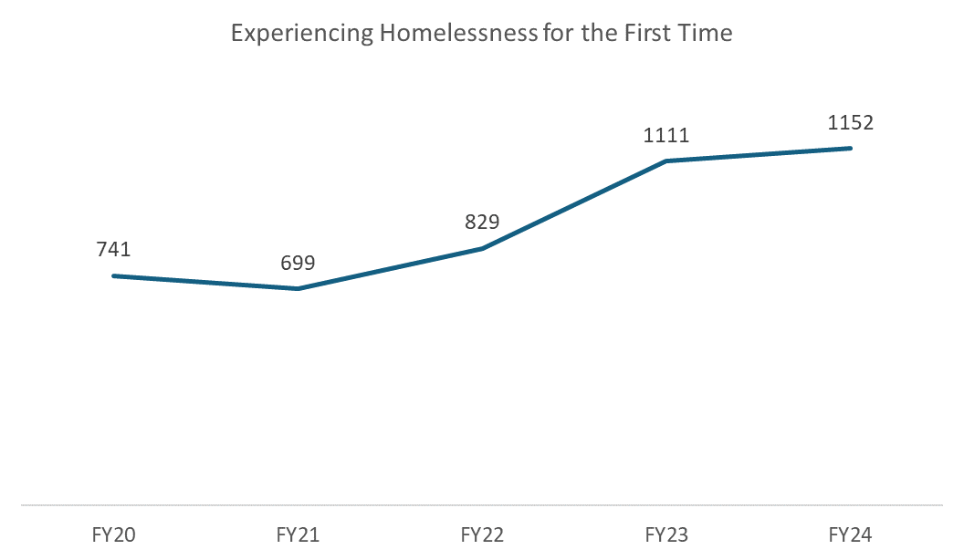
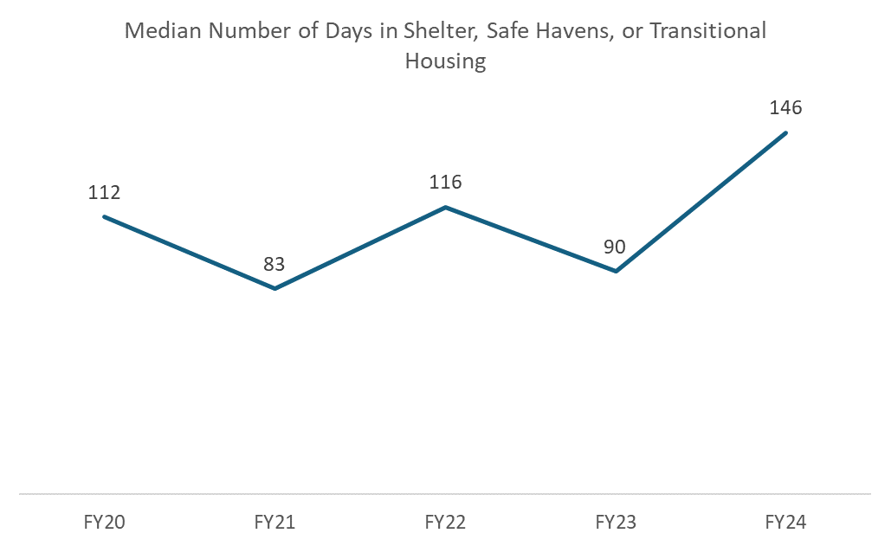
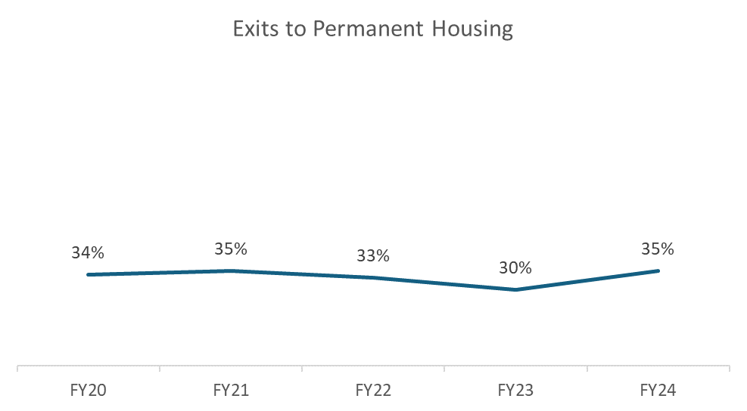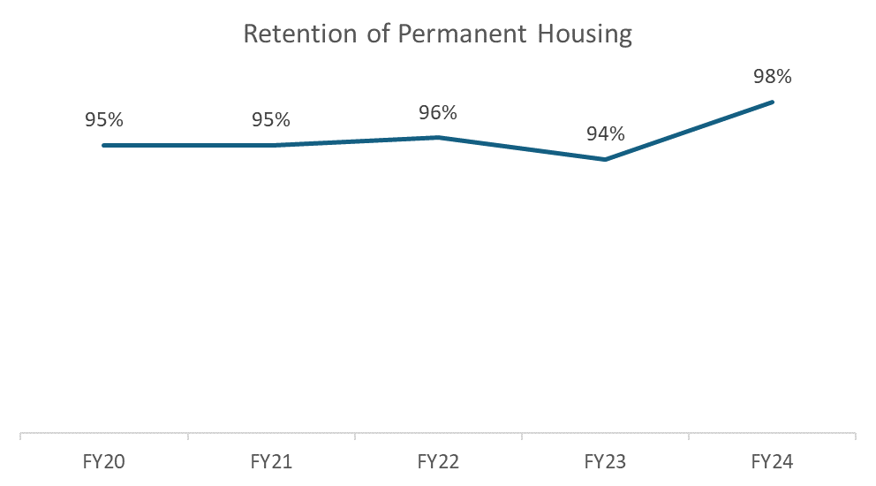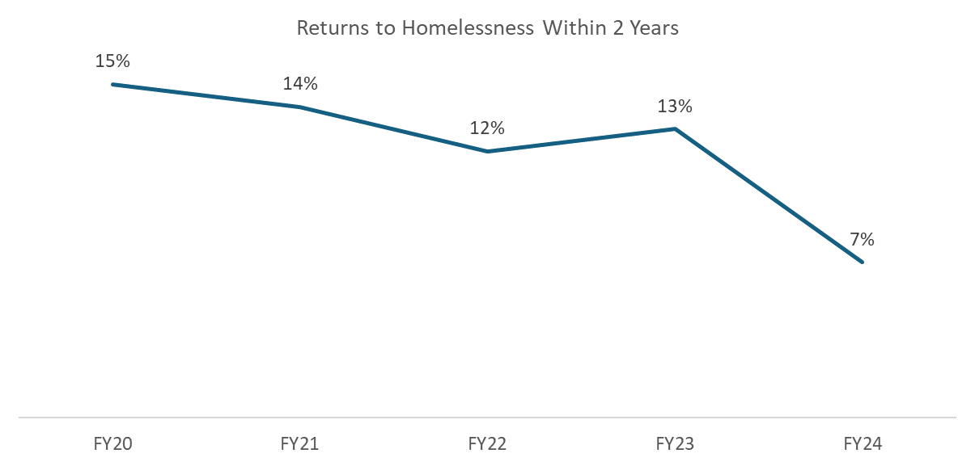Preperation for submission of the 2025 Point in Time Count and Housing Inventory Chart is currently underway; reports are due to HUD by June 13th, 2025.

Committee Updates
All CoC committees and workgroups are looking for co-chairs and for people with lived experience of homelessness to lend their voices to the work of ending homelessness in the Three County area. The CoC staff have developed a policy that provides compensation to people with lived experience for their time and perspectives. Please note that the CoC Governance Charter states that “All Funded Projects must have representatives who participate on Committees. All Committees must include at least one Board member who is responsible for communicating committee activities to the Board.”

Community Success Committee (Previously Equity and Inclusion Committee)
The Community Success Committee last met on April 16th. At this meeting, the Committee reviewed the application video submitted to the National Alliance to End Homelessness’s Workforce Development grant, as well as the Request for Information (RFI) the CoC sent out. The remainder of the meeting was spent discussing and planning the June 9th “Stronger Together Community Forum”. The Committee did not meet in May.
The next meeting is scheduled for June 18th from 11:00am-12:30pm.

Coordinated Entry
The Coordinated Entry Committee reconvened on March 4th with many new members and is now scheduled to meet the first Tuesday of every month. Since reconvening, the Committee has reviewed its goals, began discussing reevaluating the Coordinated Entry System and Vulnerability Assessment, and gone over proposed Coordinated Entry referral and HMIS user agreement forms.
The Committee also went over the 2023 Coordinated Entry system evaluation and began recording our own considerations for updates to the Coordinated Entry Assessment. As of May 15th, the Three County CoC has been approved by HUD to receive technical assistance this year from a provider with Technical Assistance Collaborative (TAC) to reevaluate the Coordinated Entry System. We soon will begin to work with the TAC provider in committee meetings to review our system policies and procedures to ensure that the Coordinated Entry system serves our participants equitably.
The next Coordinated Entry Committee meeting is scheduled for July 1st, 2025 from 10:00-11:30am.

Data Evaluation Committee
The Data Evaluation Committee last met on May 19th. So far in 2025, the Committee has grown in size by almost 50%. With a larger membership, the committee has created and sent out a new survey to inform this year’s gaps analysis to make recommendations for needed resources within Hampshire, Franklin, and Berkshire Counties. The survey can be found here- https://form.jotform.com/251033500806141
Responses are due back by the end of the day on June 10th and will be reviewed by the Committee membership along with the results of the Point in Time (PIT) Count and Housing Inventory Chart (HIC).
In addition to the survey and PIT/HIC data, the Committee’s intention is to hold at least 1 (but ideally 3) focus group or listening session where people experiencing homelessness are compensated for participation in a more open-ended discussion around needed resources in the region.
The Data Evaluation Committee has plans to assist with the implementation of the Outreach and Inventory Modules of the Clarity HMIS System after the Gaps Analysis Report is released.
The next meeting is scheduled for June 16th from 11:30am – 1:00pm.

Domestic Violence (DV) Expansion
The DV Expansion Workgroup met on April 10th and May 8th.
Meetings in April and May were used to reorganize ideas and planning for additional community training opportunities. The committee reviewed materials that are on Talent LMS from 2024 DV 101 Recordings, along with survey data collected from attendees. The committee will be looking forward to working with consultants in upcoming meetings to further refine our community education and awareness needs.
The next meeting is scheduled for Thursday June 12th from 2:00-3:30pm.

People with Lived Experience (PLE) Action Board
The PLE Action Board last met on April 3rd. During the April meeting the group continued to organize their list of actions and goals that they would like to complete over the next year. Some of the mentioned items are, a “Homeless Utility Handbook”, doing another round of the Summer Cooling Kits, and working with the CoC to conduct a Summer PIT count. The group had scheduled a 2-hour in person meeting for May but was unable to meet due to various cases of illness. The group participated in a focus group to assist Destination Home in Santa Clara County California to identify Leadership gaps. The second round of LETA students have started to finish their training and are hopeful of moving forward by working with the National Coalition for the Homeless more directly.

The next meeting is scheduled for June 5th.

Ranking and Evaluation Committee
The Ranking and Evaluation committee has not met since February 27th, which was before the last CoC Board meeting.
During the February meeting the committee focused on Subrecipient Monitoring and Evaluation with a discussion on whether to implement subrecipient monitoring in 2025 and how it will be carried out in the coming months. The group provided past monitoring reflections and feedback was gathered on last year's monitoring process, including a questionnaire sent to subrecipients and an Excel sheet used by COC staff for scoring.
The next meeting will likely be held in July, after Subrecipient Monitoring is complete.

Reimagining Interim Housing Workgroup
The Reimagining Interim Housing Workgroup last met on May 2nd.

In March/April, the Workgroup began creating the Action Plan. Most of the March meeting was spent discussing the Emergency Assistance (EA) system. A major issue within that system is a lack of information/understanding/clarity, for both participants and staff. The Workgroup identified the following as possible solutions: provide more training for caseworkers on EA, especially since so many new requirements have been instituted in the past year; and map out the workflow to understand where and what the barriers in the system are. In April and May, the Workgroup discussed and brainstormed solutions/strategies/next steps for the following items: hospitals discharging people to homelessness; Organizational issues among organizations providing shelter/interim housing; Lack of confidentiality esp. in DV cases—ability to work with survivors in confidential spaces, ensure protection of information, etc.; Misinformation/poor guidance that is coming from a good place; Limited physical capacity; Distrust of system due to past experiences; lack of safe grievance protocols.

Additionally, Shaundell and Emma presented an update on the Reimagining work at the Fair Housing and Civil Rights Conference in May 2025. The Workgroup spent some time during the May meeting discussing what they would like presented at the conference.

The next meeting is scheduled for June 26th at 10:00-11:30am.

