Three County CoC (MA-507) – Quarterly Board Report (March 2026)
This report was compiled for dissemination by March 10th, 2026, prior to the March 19th, 2026, Full Membership Annual Meeting.

Contents
Director Updates 1
Fiscal Updates 5
Compliance Updates 7
Coordinated Entry System Updates: 8
HMIS Lead Updates: 12
Committee Updates 14
Community Success Committee 14
Coordinated Entry Committee 14
Data Evaluation Committee 14
Domestic Violence (DV) Expansion Committee 14
People with Lived Experience (PLE) Action Board 14
Ranking and Evaluation Committee 14
Reimagining Interim Housing Workgroup 14
Landlord Engagement Workgroup 14

Director Updates:
We are happy to report that as of Wednesday 03/10/2026 the CoC staff has been working diligently during this time of uncertainty with everything that is happening around the FY25 Notice of Funding Opportunity from HUD.
Update on FY25 CoC NOFO and Federal Context (as of today):
- Notification from HUD that the FY 2024-2025 Continuum of Care (CoC) and YHDP Funding Opportunity – e-snaps Open on 01/09/2026
  - 2024-2025 Continuum of Care (CoC) and YHDP Funding Opportunity – e-snaps Open
  - Submission Deadline: Monday, February 9, 2026 at 8:00 PM ET
  - On Friday, January 9, 2025, HUD opened the FY 2024 – FY 2025 Continuum of Care Competition and Renewal or Replacement of Youth Homeless Demonstration Program grants NOFO (FY24-25 CoC NOFO ) with an application submission deadline of February 9, 2026, at 8:00 PM ET.
  - Projects that were awarded FY 2024 funds and are not being reallocated or replaced by the CoC may be eligible for selection for FY 2025 funds using their FY 2024 application submission and are not required to apply for renewal for FY 2025 funds (I.B.2.c).
- CoC submitted written confirmation to HUD on 02/02/2026
  - Per instructions by HUD, the CoC submitted written confirmation via email stating:
    - The Three County Continuum of Care (MA-507) will not submit any applications or a priority listing under the FY 2024–FY 2025 NOFO.
    - MA-507 does not have any new or renewal projects that meet HUD’s requirements for submitting renewal project applications. We are seeking to renew projects awarded in the FY 2024 CoC Program Competition.
  - As of today 03/04/2026
    - The CoC has not received a response from HUD by way of an award letter, or grant agreements for FY 25 funding.
- Continuum of Care Program lawsuit update:
  - Per NAEH communication:
    - The U.S. Department of Housing and Urban Development (HUD) filed an emergency motion to end the Preliminary Injunction that temporarily stopped the December 2025 CoC Notice of Funding Opportunity (NOFO). Last week, the Alliance’s legal team submitted a strong set of arguments in opposition.
    - And on Friday 02/27/26, the Court ruled in our favor. Specifically, the Court agreed that the Alliance’s members and co-plaintiffs “continue to face imminent, irreparable harm.” Based on the Court’s Friday ruling, the Preliminary Injunction remains in place.
    - However, yesterday HUD formally appealed the Court’s decision and asked an appeals court to suspend the Preliminary Injunction while their appeal is heard.
      - According to MHSA: On March 6, the District Court denied HUD’s request to stay the preliminary injunctions pending resolution of the appeal, explaining: “the Court concludes that its issuance of a stay at this juncture will substantially injure Plaintiffs by subjecting them to the upheaval and service gaps caused by Defendants attempt to implement the December 2025 NOFO on an expedited basis.”
      - According to NAEH this was expected, and that they will continue to work around the clock with their co-plaintiffs and legal counsel to put forth another strong set of arguments in opposition.
- HUD PD&R Quarterly Update on Homelessness:
  - I was unable to join this update, Wendi joined and MHSA has provided a summary of what was reviewed in this meeting:
    - HUD held an event on March 4 discussing its approach to the CoC program. The full list of speakers is available here.
    - Dr. Robert Marbut and Caitlyn McKenney echoed much of what we have heard from HUD in recent months about its policy shift. Their points included:
    - HUD’s desire to return to a “balance,” a “true continuum” – meaning a balance of emergency shelter, transitional housing, and permanent housing.
    - A focus on increasing earned income, not income from benefits, and exits to unsubsidized housing.
    - “Healthy competition,” engaging faith-based organizations, a focus on self sufficiency.
    - Caitlyn McKenney said that it is false that people will become homeless due to this – that instead this is a change in how and where people will be served.
    - Regarding the FY2026 CoC NOFO, Caitlyn McKenney said HUD’s action so far, and the executive order, are all very clear signals of the policies and reforms HUD will continue to be focused on implementing.
- MHSA Home and Healthy for Good Funding:
  - The Massachusetts Housing and Shelter Alliance (MHSA) has generously offered to help the Three County CoC’s PSH projects with early expiration dates with some financial support to extend your contracts until June 30th.
  - This funding is considered MATCH.
  - Many of the projects have been working with Wendi to extend thoer contracts as far out as they were able to with their current funding. These additional funds from MHSA will allow PSH projects to extend further. This is beneficial because contracts that start July 1st or later have a higher likelihood of having contracts in place by the start date and access to funds faster. This will also further assist projects next year if significant changes are made to funding eligibility by HUD.
  - Based on the projects current contracts and current spending, Wendi estimated that to accomplish the goal of getting PSH projects out of the 2/01 start date to 7/01 projects would need $510558.00, which MHSA approved.
CoC Priorities and Initiatives continue:
- Point in Time Count
  - The CoC staff, service providers, advocates, and members of the PLE Action Board worked together to conduct the 2026 Point in Time Count.
  - This was a service-based count that took place the last week of January, specifically for the night of January 25th.
  - The CoC is still collecting paper surveys from the community, as well as getting information from our shelter providers.
  - We can share some very preliminary shelter numbers:
    - 435 people total so far, 387 individuals and 35 people in families
    - We're still waiting on data from EFC and Soldier On which could add 100 plus people to the count and are still confirming most of the shelter counts we have now.
    - This information does not include our unsheltered numbers.
  - The CoC held community events to complete PIT Count surveys and provide our unhoused neighbors with warming items, donated by community members and the PLE Action Board.
    - Items included thermal clothing, socks, gloves, ChapStick, sleeping bags, blankets, insulated travel mugs, flash lights, batteries, and toe warmers.
- Coordinated Entry Evaluation
  - Our consultants with TAC are ready to get the virtual listening sessions scheduled! The purpose of the listening sessions is to understand the firsthand experience of using the Assessment Tool and to gather actionable feedback to make it better. Our primary goals are to:
    - Identify strengths of the current tool.
    - Uncover barriers or bottlenecks for staff and households.
    - Gather insights to directly inform future improvements.
  - These sessions will be facilitated conversations where there are no right or wrong answers—only honest, candid feedback. To protect your privacy, feedback will be synthesized into a general summary, and individual comments will not be attributed to specific participants.
    - Listening Session Details: Housing Assessors & Frontline Staff
      - Date & Time: Monday, March 16 9:30-11:00AM OR Thurs, March 26 11-12:30PM
    - Listening Session Details: People with Lived Experience & Expertise
      - Date & Time: Thurs, March 19 2:30-4:00PM
    - Listening Session Details: Victim Service Provider (VSP)/Domestic Violence Provider Staff
      - Date & Time: Mon, March 23 2-3:30PM
    - Registration Link: https://forms.gle/bpopjGKeFMrohGA58
- Three County CoC Tenant Preparedness & Stability Session
  - Nichele Carver held this listening session on Saturday February 28th virtually over zoom.
    - The tenant listening session was held with participants currently enrolled in Permanent Supportive Housing programs within the Three County Continuum of Care. The purpose of the session was to provide transparent information about potential federal housing funding changes and to create space for tenants to share concerns, ask questions, and discuss how they would prepare if housing resources changed.
    - Attached in Board Report Email:
      - Board Summary
- Upcoming Trainings
  - Financial Literacy Training:
    - March 28th : Time (TBA); a survey has gone out to the community to get information about what time/date/modality work best for the participants, and what they would like to learn about.
    - We ask that you please share the survey to all your participants.

Fiscal Updates
We are still pending FY25 awards.

ALL HUD FY23 Projects have been closed and APRs submitted.
The following HUD FY24 projects have been closed and are going through APRs: IHS, Louison House (LH) TH and Northern Berkshire

We received a very generous match for projects from MHSA’s Home and Healthy for Good Program. The funds are to be utilized by PSH projects that need additional funding and will help us until June 30, 2026. The projects are either utilizing the funds in FY24 or FY25 as matching funds, depending on their period of performance (POP). It is very important that the MHSA invoices be submitted prior to the 12th of each month after expenses have been incurred.
HUD FY24 Project Utilization | Contract Start | Original Contract End Date | Extension #1 End Date | Extension #2 MHSA End Date | HUD Total Sub-Recipient Award | MHSA Additional Match Funding for Extension | HUD Point Billed in Contract | HUD Month Billing Processed Through (Month/Year) | HUD Current Utilization (through last billing) | Change in Utilization Rate w/ MHSA Match
CoC Projects FY24
HUD A Positive Place | 2/1/2025 | 1/31/2026 | 2/28/2026 | 6/30/2026 | $159,976.00 | $46,484.00 | 92% | Jan-26 | 89% | 69%
HUD Salasin RRH | 6/1/2025 | 5/31/2026 | n/a | n/a | $361,711.00 | n/a | 67% | Jan-26 | 29% | n/a
HUD CHD PSH A & B | 2/1/2025 | 1/31/2026 | 2/28/2026 | 6/30/2026 | $845,562.00 | $273,607.00 | 92% | Jan-26 | 98% | 74%
HUD MOC 3 County PSH B | 2/1/2025 | 1/31/2026 | 2/28/2026 | 6/30/2026 | $651,082.74 | $215,991.00 | 92% | Jan-26 | 99% | 76%
HUD LH 3 County PSH A | 2/1/2025 | 1/31/2026 | 2/28/2026 | 6/30/2026 | $194,479.26 | $57,616.00 | 92% | Jan-26 | 94% | 68%
HUD DIAL/SELF TH/RRH-PH | 2/1/2025 | 1/31/2026 | 3/31/2026 | Pending 6/30/2026 Approval | $102,834.00 | n/a | 71% | Jan-26 | 59% | n/a
HUD Independent Housing Solutions* | 2/1/2025 | 1/31/2026 | n/a | 6/30/2027 | $165,186.00 | $75,019.00 | 100% | Jan-26 | 100% | FY25
HUD Louison House TH | 2/1/2025 | 1/31/2026 | n/a | n/a | $141,241.00 | n/a | 100% | Jan-26 | 100% | n/a
HUD Louison House Northern Berkshire PSH* | 2/1/2025 | 1/31/2026 | n/a | 6/30/2027 | $206,631.00 | $86,662.00 | 100% | Jan-26 | 100% | FY25
HUD Louison House Bracewell | 2/1/2025 | 1/31/2026 | 3/31/2026 | 6/30/2026 | $124,960.00 | $28,786.00 | 86% | Jan-26 | 90% | 73%
HUD Village Center Apartments | 2/1/2025 | 1/31/2026 | 6/30/2026 | n/a | $79,853.00 | n/a | 59% | Nov-26 | 44% | n/a
YHDP Projects FY24
HUD YHDP DIAL/SELF RRH Franklin | 1/1/2026 | 9/30/2025 | 12/31/2025 | n/a | $86,272.00 | n/a | 8% | Jan-26 | 7% | n/a
HUD YHDP Gandara SHINE TH-RRH | 10/1/2025 | 9/30/2025 | n/a | n/a | $472,053.00 | n/a | 33% | Jan-26 | 21% | n/a
HUD MYHP MOC Youth Housing | 10/1/2025 | 9/30/2025 | n/a | n/a | $201,048.00 | n/a | 33% | Jan-26 | 43% | n/a
HUD CAPV Youth Nav/RRH | 10/1/2025 | 9/30/2025 | n/a | n/a | $220,992.00 | n/a | 33% | Jan-26 | 19% | n/a
* HUD Subrecipient Contract Ended 1/31/2026 - Match funding to be applied to the FY25 HUD Contract, requesting extension to 6/30/2027 on FY25 contract

FY24 HUD DIAL/SELF TH PH-RRH Joint has requested no cost extension until June 30, 2026. With a reduction in units. SNAPS refused the reduction in units. They are still reviewing extension information.
New Forms have been drafted for FY25 subrecipients. We asked for feedback during the next office hours on March 18th from 10-11 am. We would like as many people to attend as possible. There are changes (hopefully what you see as improvements) to almost all the forms.
Office hours are still the 3rd Wednesday of the month from 10:00-11:00.

Compliance Updates
Subrecipient Monitoring
We are proposing to make some changes to Subrecipient Monitoring that would reduce the documentation Subrecipients would need to submit for review, in some of the following ways:
- Most program policies would only be requested for annual review if a Subrecipient met a specific risk threshold or an incident related to procedures had occurred
- Reducing narrative questions
Distinguishing between program compliance and performance
- Subrecipient Monitoring will focus on CoC and YHDP requirements and narrow the scope to items that HUD has included in their Monitoring Guide for CoC programs.
- Subrecipient Performance is tied to project outcomes, local priorities, and other standards established by the Continuum of Care’s board, committees, and membership.
Subrecipient Monitoring and Ranking
- We anticipate that the next NOFO from HUD will include many of the priorities reflected in the 2025 NOFO currently in litigation.
- As the collaborative applicant, we intend to hold meetings with the Ranking and Evaluation committee to propose updating how monitoring and performance are scored and ranked.
- The existing monitoring tool used by the CoC has certain points assigned to meeting program requirements, which ultimately create more scored point items for some projects with the most requirements than other with less. For example, PSH projects have more documentation tied to program eligibility for participants than RRH or TH projects.

Monthly Office Hours
- Office hours have not been held in recent months, as many projects have been focused on the 2025 NOFO, pending litigation, and project renewals
- We welcome suggestions for any topics desired by projects to be reviewed or updated and presented in Office Hours!
- Future office hours will cover some of the following topics:
  - Housing Standards Inspections and Lead-based Paint requirements
    - HUD has delayed implementation of NSPIRE until 10/2026 for CoC and ESG Programs. However, we will begin building our own materials to use while we await implementation guidance and tools from HUD.
  - Documenting Chronic Homelessness and Disability for PSH
    - While PSH projects did well in Subrecipient monitoring, some of the minor revisions to forms and documentation standards are being updated to improve how referring partners in Coordinated Entry assist with documenting eligibility. These changes will be first introduced to Subrecipients for feedback/revision before they are shared with referring partners.

Coordinated Entry System Updates:

- Since December 2025, the Three County CoC has onboarded 16 new Coordinated Entry Assessors to be trained to either complete vulnerability assessments and/or attend Case Conferencing Meetings.
- Since September 2025, the Coordinated Entry Specialist has been hosting monthly live Coordinated Entry Process and Assessment Tool trainings available for new Coordinated Entry Assessors and those who would like to review the process. The latest training is available on our TalentLMS training platform for those who are interested in becoming coordinated entry assessors to view.
- Since our last board report in December 2025 the Coordinated Entry system has seen the following referrals made into CoC-funded housing:
- Transitional Housing (TH): 9 total
- Rapid Rehousing (RRH): 3 total
- Permanent Supportive Housing (PSH): 10 total

- The Three County CoC’s Existing Projects are:
  - A Positive Place (APP) (Cooley Dickinson)
  - Adult Independent Living (Construct)
  - DIAL/SELF RRH Franklin
  - DIAL/SELF TH/RRH-PH
  - Gandara SHINE TH/RRH
  - Independent Housing Solutions (IHS) PSH
  - Louison House Bracewell Youth PSH
  - Louison House Pittsfield PSH
  - Louison House Northern Berkshire PSH
  - Louison House TH
  - Making Opportunity Count (MOC) PSH
  - Making Opportunity County (MOC) Youth PSH
  - Community Action Pioneer Valley’s Youth & Workforce Development Programs (CAPV Y&WFD) Youth RRH
  - Salasin Project RRH
  - Village Center Apartments (Hilltown)

- MOU Partnership Updates
  - Hearthway
    - Permanent Supportive Housing (PSH)
      - The Three County CoC has a partnership with Hearthway for them to accept referrals through the Coordinated Entry System for their newly constructed SRO PSH units. There are 9 PSH units located at First Street and 28 PSH Units located at West Housatonic Street in Pittsfield.
      - Tenant selection has been completed through the Coordinated Entry prioritization process for all 9 units located at First Street and all 28 units located at West Housatonic Street. All units at First Street have been filled, and Hearthway is processing applications to the West Housatonic Street apartments. The projected move in date for the West Housatonic Street apartments was previously early February, but there have been delays due to the wait for a certification of occupancy for the new building.

  - CSO
    - Rapid Rehousing (RRH)
      - The Three County CoC has a partnership with CSO to take referrals from Coordinated Entry for their Rapid Rehousing (RRH) Assistance. The assistance can be used for either unit move-in costs, including first and last month's rent and security deposit. In some cases, the funds can be used to settle past-due arrears or to obtain new copies of an individual’s documents, such as IDs or Birth Certificates.

    - Permanent Supportive Housing (PSH)
      - Referrals for the 36 PSH units will come from the CE system in the following manner:
        - Referral by the CoC from the By Names list, using the priorities and preferences established in the Tennent Selection Plan
        - CSO will screen and accept the referral to move on to the application process
        - The referring case manager in collaboration with CSO case managers will work with the referred participant on the application for HRA Section 8 subsidy
        - Once approved for Section 8, lease up and occupancy of the unit can begin
      - Updates:
        - Project is projected to be ready for occupancy by June 15th, 2026 (the previously scheduled occupancy ready date was by end of May 2026)
        - Initial coordination has begun between all the parties involved.
        - The CoC has begun the process of identifying referrals for the units as of March 11th, 2026. Official referrals from the CE/BNL will start in early April.
        - After the coordinated entry referral has been made, participants will need to complete voucher applications, providing their essential documents such as picture ID, SS card, birth certificate, income, bank statements, etc., and attend a briefing to learn about the program.
        - CSO will assist to support document gathering specifically for individuals that are previously engaged with CSO.

DV Coordinated Entry System Updates:

Case Conferencing:
DV case conferencing continues to meet every other Monday, acting as a space for providers to problem solve, discuss available resources and solutions, and make referrals to the RRH project (when there are openings).
Salasin RRH Project:
Since December 2025, 3 referrals have been made and a total of 2 households were safely housed. Since the project began, there have been a total of 9 referrals (with one declining, so 8 successful) and 6 households safely housed.

HMIS Lead Updates:
The HMIS reporting season is still underway and is expected to last until April or May now. The CoC has successfully submitted the Longitudinal Systems Analysis (LSA) report to HUD, which looks at how people who are utilizing the homelessness response system move through the system itself and how different paths lead to different outcomes for different populations. This report requires a lot of back and forth communication with HUD who will ask the CoC to clean different aspects of our data until the correction or explanation is satisfactory. All errors were resolved and all warnings were sufficiently addressed or explained prior to the report deadline. The second report due was the System Performance Measures (SPM) which are crucial to our understanding of recidivism, rates of exit to permanent housing, increases in income, the average length of time people experience homelessness, and the number of people experiencing homelessness for the first time. The system performance measures are also very heavily weighted in HUD's scoring structure for the FY25 NOFO (and typically is in most NOFO processes). The FY25 System Performance Measures were submitted on March 4th prior to the deadline with no errors or warnings. Results from some of the measures included in this report are shown below- overall the CoC saw improvements in all areas except for income growth and the average length of time people experience homelessness.
The 2026 winter point in time count took place on January 25, 2026 and unsheltered and sheltered results are still in the process of being compiled and finalized for the final report and submission to HUD. Currently HUD has not shared dates letting us know when the report will open and be due.
System Performance Measure Trends:
Measure 1 – Length of Time Experiencing Homelessness
This measure includes data on length of stay in shelter or TH and also includes length of time since the ‘approximate date homelessness began’ field in HMIS enrollment screens. Both of these data points are also looked at as an average and as a median length of time and there are additional versions which include those enrolled in housing programs who haven’t moved in yet. For performance evaluation by HUD we focus on the median length of days in shelter, safe havens, or transitional housing which for the most part has continued to increase since FY21.
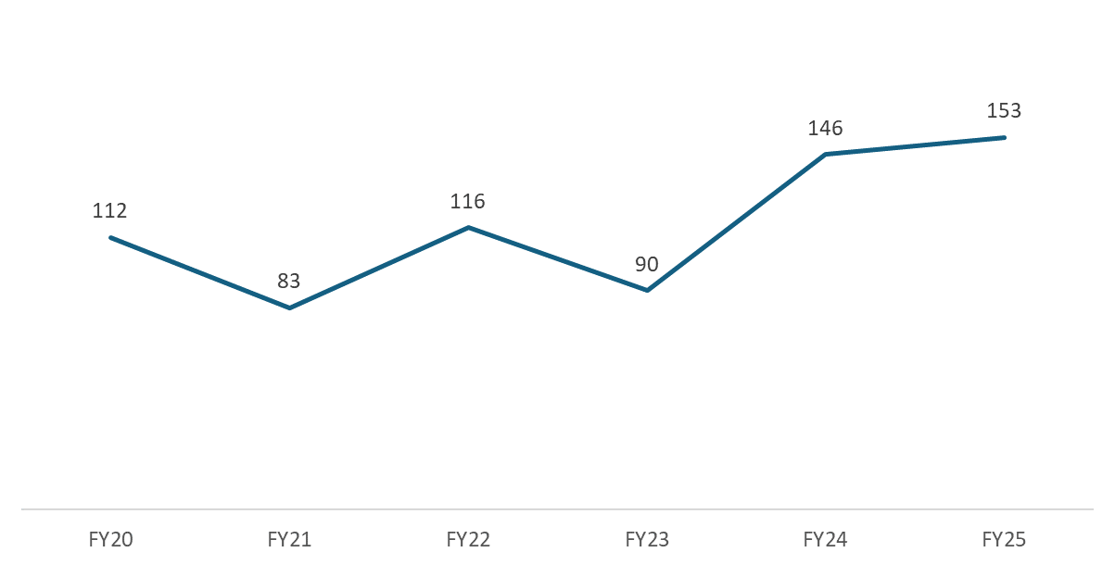
Measure 2 - Returns to Homelessness
This measure looks at the percentage of people who exit homelessness to permanent housing and then re-enroll in a shelter or transitional housing or safe haven program within the next 2 years. This measure also looks at various 6 month and year long intervals but total returns over 2 years are what we are typically evaluated most heavily on.
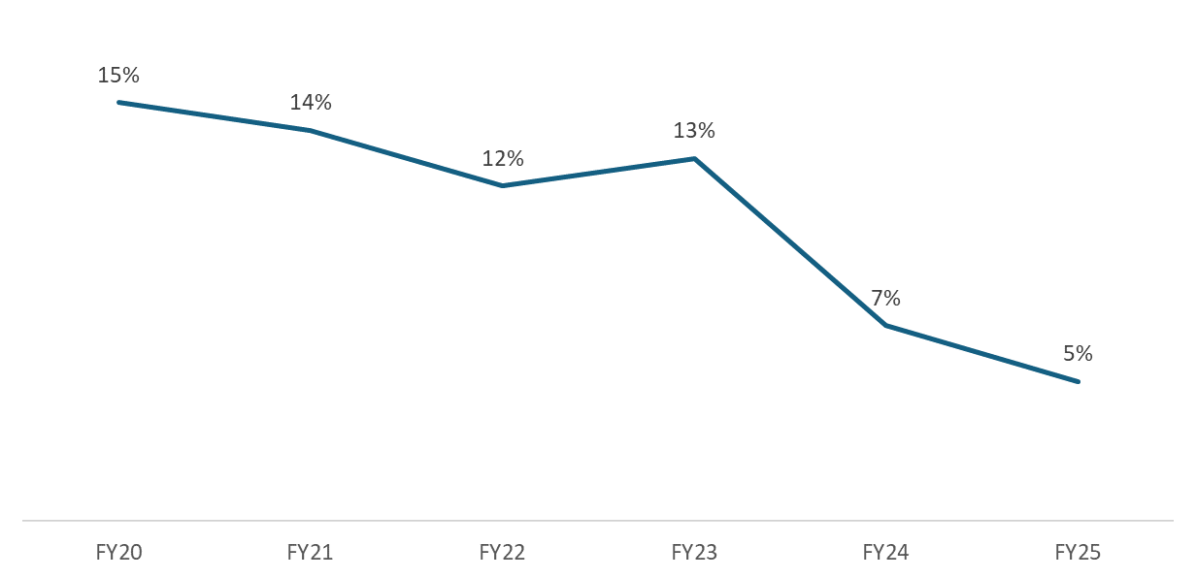
(Measure 3 is the Change in People Experiencing Homelessness and is determined by the Point in Time Count)
Measure 4 – Income Growth in CoC Funded Projects
This measure was not included in CoC application scoring in past recent years but there is a lot of evidence that a future NOFO competition will be evaluating CoCs on increases in employment income in CoC funded projects, although it’s unclear if the emphasis will be on system leavers or stayers, both are shown below and are on a downward trend.
Adult Stayers-
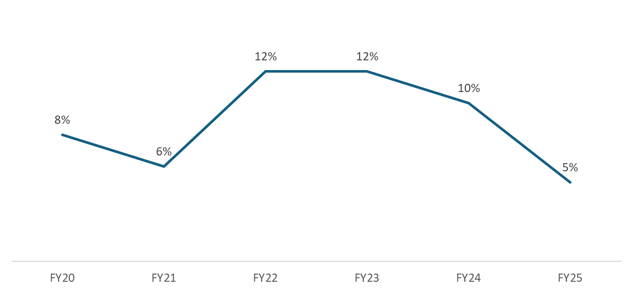
Adult Leavers-
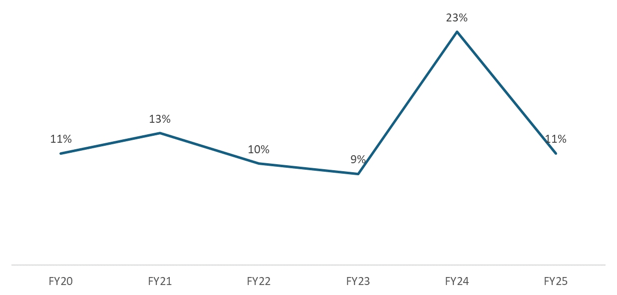

Measure 5 – Number of People who Become Homeless for the First Time
The number of people becoming homeless without prior enrollments or history in HMIS is calculated for both shelter, safe haven, and transitional housing programs only and also when permanent housing enrollments are factored in. For both FY25 outcomes, the number of people experiencing homelessness for the first time has decreased for the first time since FY21.
New Enrollments in ES, SH, or TH
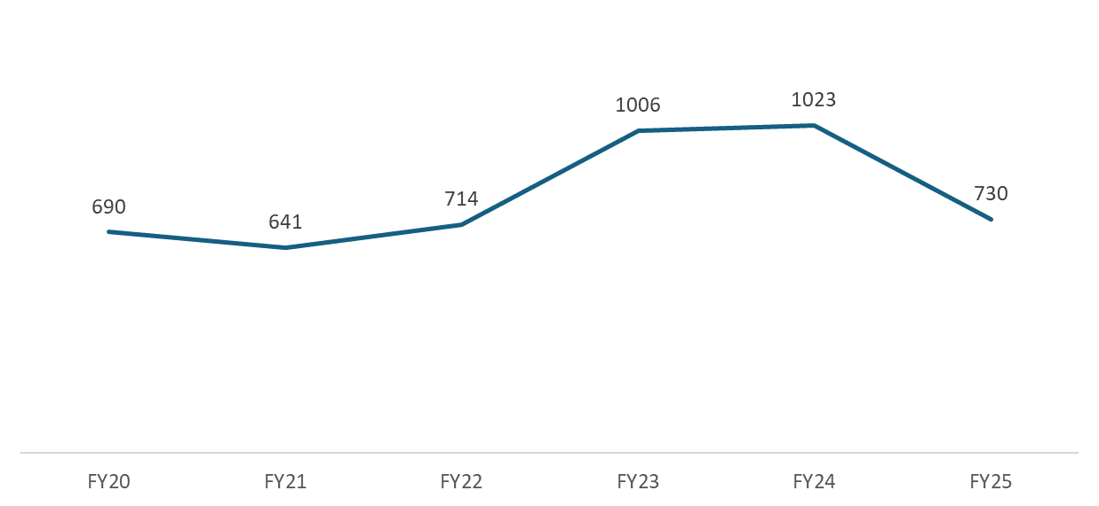
Measure 6 is not applicable for the Three County CoC currently as it evaluates CoCs who are allowed to serve people experiencing category 3 homelessness.
Measure 7 – Successful Exits to and Retention of Permanent Housing
The last measure evaluates the percentage of people who exit street outreach to permanent housing, the percentage of people who exit shelter, safe haven, or transitional housing to permanent housing, and the percentage of people who remain in a permanent housing program or exit to other forms of permanent housing during the reporting year. Retentions of permanent housing have been consistently fairly high in recent years (between 94% and 98% over the past 6 years) and has remained at 98% for two years in a row. Exits to permanent housing from shelter, transitional housing, or safe haven have typically been much lower- as low as 30% in FY23- but in FY25 we see a positive increase to 43% exits to permanent housing.

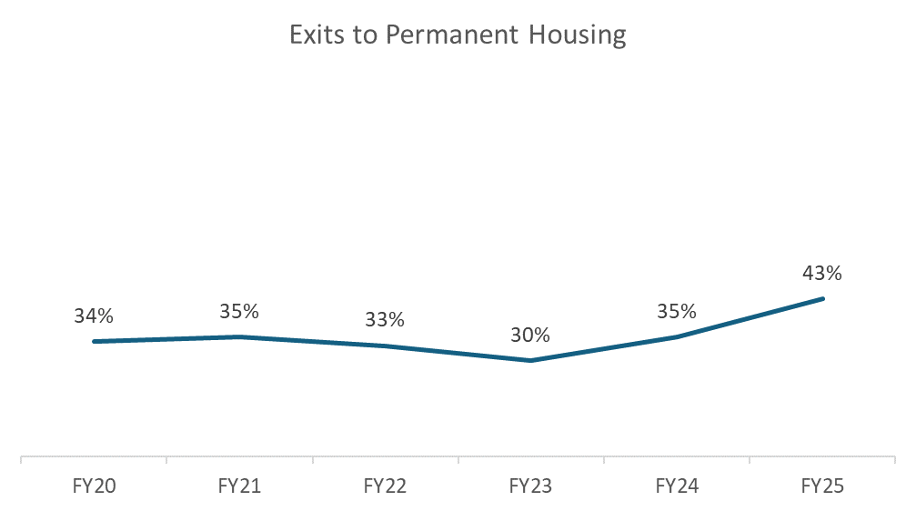
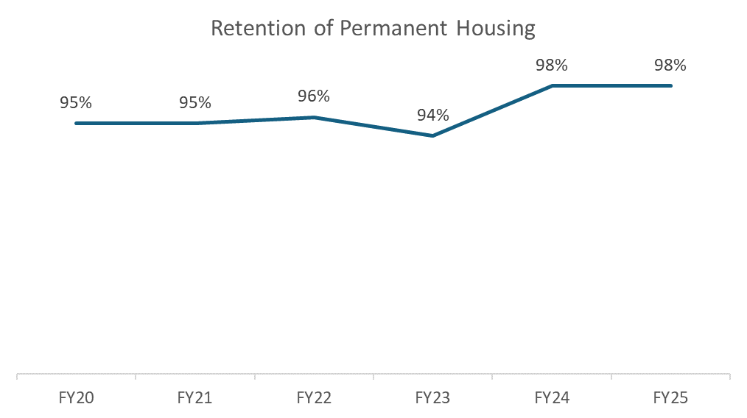

Committee Updates
All CoC committees and workgroups are looking for co-chairs and people with lived experience of homelessness to lend their voices to the work of ending homelessness in the Three County area. The CoC staff have developed a policy that provides compensation to people with lived experience for their time and perspectives. Please note that the CoC Governance Charter states that “All Funded Projects must have representatives who participate on Committees. All Committees must include at least one Board member who is responsible for communicating committee activities to the Board.”

Community Success Committee
The Community Success Committee last met on January 21st. At this meeting the Committee reviewed the responses to the fall Climate Survey, focusing specifically on training suggestions which include: working with older populations/aging participants, de-escalation, benefit programs and changes (SSI, SSDI, SNAP, Medicaid), mental health, resource navigation, and probate court and child support. The CoC connected with the Greenfield Court Service Center to hold a training on court-related topics. The training was held on February 26th, and 34 individuals attended. The Committee also discussed how to increase utilization of our TalentLMS site (where the majority of our trainings are recorded and uploaded).
The next meeting is scheduled for March 25th.

Coordinated Entry Committee
The Three County CoC is currently working with our assigned technical assistance providers from the Technical Assistance Collaborative (TAC) to reevaluate the Coordinated Entry System. Based on the priorities that the CE Committee has identified, the evaluation process has been split into two parts that will need both further engagement from the CE Committee and our community. The evaluation will include examining our Coordinated Entry Assessment Tool with community feedback and assessing the Coordinated Entry System as a whole.
During the most recent Coordinated Entry Committee meetings, the group worked with our TA providers to identify which questions on the assessment tool should be reviewed in the upcoming Assessment Tool Evaluation Community Listening Sessions. These Listening Sessions will be occurring in the month of March, and there will be in person Listening Sessions with the TAC providers in April for feedback on the CE System as a whole. After these listening sessions, the Coordinated Entry Committee will hear from the TA Providers about the feedback shared at the Listening Sessions and a summary of the recommendations that the TA providers have for improvements to our Coordinated Entry System. In the meantime, we will not be holding a CE Committee meeting in April as our TA providers and CE Committee members will be busy with the Listening Sessions.
The next meeting is scheduled for May 5th 11:30am – 1pm.

Data Evaluation Committee
The Data Evaluation Committee has been working on leading the CoC's Gaps Analysis report, which consisted of a survey as well as listening sessions with people with lived experience of homelessness. Recommendations for the report have been made and a draft has been developed and is being reviewed and edited by the committee currently. The Data Evaluation Committee will present the draft to the CoC Board before making it publicly available. Outside of CoC eligible funding opportunities, the biggest resource seen as a gap/need across the Three County region is homelessness prevention.
In addition to the Gaps Analysis, the Data Evaluation Committee has been assisting the CoC with planning and implementing the use of the ‘Inventory Module’ within the CoC’s CAPV Clarity HMIS. When implemented, this module will add a current inventory of available and occupied permanent housing beds and units within the Three County CoC which participate in the Coordinated Entry system. There is a small amount of basic inventory information in the HMIS currently but this new module will include eligibility information, special characteristics about a unit, and occupancy status which will assist the referral process through coordinated entry. Implementing the Inventory Module involves collecting a considerable amount of information from housing providers and building out the structure in the system- the Data Evaluation Committee is helping with this implementation by reviewing and brainstorming unit information and naming conventions for the setup process.
The next Data Evaluation Committee Meeting is April 13th from 11:30am-1pm.

Domestic Violence (DV) Expansion Committee
The DV Expansion Committee last met on February 20th.
At this meeting, the Committee agreed to move forward with the ‘crisis tool’ process that began in 2023. The Committee’s vision is that a short DV screening tool will be integrated into shelter intake processes. This will allow shelter staff to connect individuals (via a warm handoff) with local Victim Service Providers. The exact questions have not been decided on, but it will look similar to many existing screening tools. Next steps include bringing shelter staff into the conversation, finalizing the questions, and developing training and guidance.
The next meeting is scheduled for March 12th.

People with Lived Experience (PLE) Action Board

The PLE Action Board last met on February 5th. During the January meeting, the group went over PIT trainings and events. The group reviewed the monthly calendar that is located on the CoC website, which they had requested. The group then started to review the suggestions to the PLE Action Plan, which was composed during the November in-person meeting alongside members of the YAB. The CoC also shared a survey that we asked the PLE Action Board members to complete on how so far the CoC was engaging with them and how we could do better. The group was asked to provide expansion ideas in an email to the CoC that they were provided compensation for. During the February meeting the group were informed about the EOHLC Fair housing and listening session, informed about the upcoming Financial Literacy training, and provided with the survey that the consultant has requested paticipants complete, informed abou th Court training that would also be happening, and provided with an update on the Targeted Universalism Workgroup. CoC staff let the group know that the Destination Home funding would be endiong, and went over the harsh reality about the limitations of HUD funding in regard to the work the PLE Action Board does. We are hopeful that we will get this funding again. The group started planning for the March in person meeting, and continued to review and update pieces of the PLE Action Plan.

The next meeting is scheduled for March 26th and will be in-person at Forbes Library from 2:30p – 4:30p.

Ranking and Evaluation Committee
The Ranking and Evaluation Committee last met on September 4th at 10:30am.
Following the issuance of the 2025 NOFO in November, the committee had planned to meet on December 22, 2025, but was canceled and given the opportunity to vote and provide feedback on an updated scoring tool to align with the 2025 NOFO priorities and requirements.

We will plan to hold a meeting soon to propose an updated scoring tool.

Reimagining Interim Housing Workgroup

The Reimagining Interim Housing Workgroup last met in the fall. This work will start to ramp up again as Emma and Shaundell will be presenting for a third year in a row at the 2026 Fair Housing and Civil Rights conference at the end of May. Emma will be providing an update on the local aspect of the work , and Shaundell will provide an update on netional aspect of the work.

Landlord Engagement Workgroup

The CoC is excited to restart the Landlord Engagement Workgroup! This workgroup will need to reestablish goals and objectives and act as a space for peer-to-peer learning for housing search and landlord engagement for providers of housing assistance.

We will hold our first meeting on Wednesday April 1st at 10:00 AM on Zoom

Other strategies that will be explored include shared housing models, tenant readiness programming, and other community/system-wide strategies. Community members and Subrecipients interested in joining should email nburtzos@communityaction.us

