Three County CoC (MA-507) – Quarterly Board Report (March 2025)
This report was compiled for dissemination by March 13th, 2025 prior to the March 20th, 2025 Board Meeting.

Contents
Director Updates 1
HUD FY22 Project Utilizations 1
HUD FY23 YHDP and FY24 Project Utilizations 2
Compliance Updates 3
Coordinated Entry System Updates: 3
HMIS Lead Updates: 4
Committee Updates 5
Coordinated Entry 5
Data Evaluation Committee 5
Domestic Violence (DV) Expansion 5
Equity and Inclusion Committee 5
People with Lived Experience (PLE) Action Board 5
Ranking and Evaluation 6
Reimagining Interim Housing Workgroup 6

Director Updates:

Over the last couple of months, in preparation for potential required changes from the new administration, the CoC has been diligent in reviewing and making changes to its website, Written Standards, Governance Charters, and Subrecipient Manual, we have scheduled a membership meeting to vote on the suggested changes to language, and during the Board meeting we will seek final approval for these changes. We know that our CoC remains committed to ending homelessness by prioritizing the needs of our community and advancing equitable, person-centered solutions. Through strong collaboration with our dedicated partners, we will continue to enhance services, expand housing opportunities, and drive change to ensure that everyone has a safe and stable place to call home. We are also happy to report that as of Wednesday 03/12/2025, late in the afternoon we started to see Grant Agreements start to come in from HUD. This is great news as we thought these agreements were going to be delayed due to recent cuts to HUD staffing. We are hopeful to work through the process of getting MOUs signed and returned to the HUD field office as soon as possible.

Another update is that because of the CE DV Expansion funding, the CoC will be looking to hire a new member to our staff that will focus specifically on addressing the needs of survivors and will address the needs of encampments across the three-county region.

HUD FY22 Project Utilizations:
General | FY 2022 Contract Utilization HUD & EOHLC State Gap (as of 1/31/2025)
Project | Contract Start | Total Sub-Recipient Award | Point Billed in Contract | Month Billing Processed Through | Current Utilization (thru last billing)
CoC Projects FY22
HUD A Positive Place | 23-Aug | $135,219.00 | 100% | January | 100%
EOHLC A Positive Place* | 24-Jul | $28,837.00 | 47% | January | 84%
Total A Positive Place |  | $164,056.00
HUD Adult Independent Living | 23-Nov | $41,992.00 | 100% | January | 100%
HUD MOC PSH | 23-Jul | $556,938.80 | 100% | January | 100%
EOHLC MOC PSH | 24-Jul | $168,199.00 | 100% | January | 100%
Total MOC PSH |  | $725,137.80
HUD DIAL/SELF TH/RRH-PH | 23-Jul | $95,041.50 | 100% | January | 93%
HUD Independent Housing Solutions | 23-Aug | $139,004.50 | 100% | January | 100%
EOHLC Independent Housing Solutions | 24-Jul | $69,502.00 | 100% | January | 100%
Total IHS |  | $208,506.50
HUD Louison House TH | 23-Feb | $134,541.50 | 100% | January | 100%
EOHLC Louison House TH | 1-Jul | $22,712.00 | 100% | January | 100%
Total LH TH |  | $157,253.50
HUD Northern Berkshire PSH | 23-Sep | $171,598.00 | 100% | January | 100%
EOHLC Northern Berkshire PSH | 24-Jul | $24,000.00 | 100% | January | 100%
Total NB PSH |  | $195,598.00
HUD Louison House Pittsfield PSH | 23-Jul | $163,646.70 | 100% | January | 100%
EOHLC Louison House Pittsfield PSH | 24-Jul | $28,288.00 | 100% | January | 100%
Total LH Pittsfield PSH |  | $191,934.70
HUD Louison House Bracewell | 24-Feb | $108,685.00 | 100% | January | 100%
HUD Paradise Ponds | 23-Mar | $29,717.50 | 100% | January | 100%
HUD Village Center Apts | 23-Nov | $68,645.00 | 100% | January | 100%
EOHLC Village Center Apts* | 24-Jul | $20,000 | 47% | January | 87%
Total VCA Hilltown |  | $88,645.00
YHDP Projects FY22
HUD DIAL/SELF RRH Franklin** | 23-Oct | $68,403.00 | 100% | September | 55%
HUD Gandara SHINE TH-RRH ** | 23-Oct | $403,166.00 | 100% | September | 95%
HUD MHA PSH ** | 23-Oct | $171,144.00 | 100% | September | 98%
HUD MHA Youth Nav/RRH ** | 23-Oct | $197,312.00 | 100% | September | 63%
* State EOHLC Family Match Funding expires September 30, 2025.
** FY22 YHDP projects that closed as of September 30, 2024.
HUD FY23 YHDP and FY24 Project Utilizations:
General | FY 2024 Contract Utilization HUD & EOHLC State Gap (as of 1/31/2025)
Project | Contract Start | Total Sub-Recipient Award | Point Billed in Contract | Month Billing Processed Through* | Current Utilization (thru last billing)
CoC Projects FY24
HUD A Positive Place | 02/01/25 | $159,976.00 | 0% |  | 0%
EOHLC A Positive Place* | 07/01/24 | $ 4,550.00 | 47% | January | 84%
Total A Positive Place |  | $164,526.00
HUD Salasin RRH | 02/01/25 | $361,711.00 | 0% |  | 0%
HUD CHD PSH A & B | 02/01/25 | $845,562.00 | 0% |  | 0%
HUD MOC PSH B | 02/01/25 | $651,082.74 | 0% |  | 0%
HUD DIAL/SELF TH/RRH-PH | 02/01/25 | $102,834.00 | 0% |  | 0%
HUD Independent Housing Solutions | 02/01/25 | $165,186.00 | 0% |  | 0%
HUD Louison House TH | 02/01/25 | $141,241.00 | 0% |  | 0%
HUD Louison House Northern Berkshire PSH | 02/01/25 | $206,631.00 | 0% |  | 0%
HUD Louison House Pittsfield PSH A | 02/01/25 | $194,479.26 | 0% |  | 0%
HUD Louison House Bracewell | 02/01/25 | $124,960.00 | 0% |  | 0%
HUD Village Center Apts | 02/01/25 | $79,853.00 | 0%
EOHLC Village Center Apts* | 07/01/24 | $5047.11 | 47% | January | 78%
Total VCA Hilltown |  | $82,458.11
YHDP Projects FY23
HUD YHDP DIAL/SELF RRH Franklin | 10/01/24 | $81,164.00 | 25% | December | 7%
HUD YHDP Gandara SHINE TH-RRH | 10/01/24 | $437,938.00 | 33% | January | 23%
HUD YHDP MHA PSH | 10/01/24 | $200,508.00 | 33% | January | 33%
HUD YHDP MHA Youth Nav/RRH | 10/01/24 | $220,632.00 | 33% | January | 23%
YHDP Projects FY24
HUD YHDP DIAL/SELF RRH Franklin | 10/01/25 | $86,272.00 | 0% |  | 0%
HUD YHDP Gandara SHINE TH-RRH | 10/01/25 | $472,053.00 | 0% |  | 0%
HUD MYHP MOC Youth Housing | 10/01/25 | $201,048.00 | 0% |  | 0%
HUD MHA Youth Nav/RRH | 10/01/25 | $220,992.00 | 0% |  | 0%
* State EOHLC Family Match Funding expires on September 30, 2025. Underutilization of Family Funding given to Village Center Apts – $2442.00

Compliance Updates
Subrecipient Monitoring
Subrecipient Monitoring will be carried out from April through May. This year, part of the monitoring will be carried out on-site at an office/location of the Subrecipient’s choosing.
Three County CoC staff met with the Ranking and Evaluation Committee on 2/27 to review some minor but meaningful updates to our Subrecipient Questionnaire.
Monthly Office Hours for Subrecipient Technical Assistance were held on:
- Friday February 14th, 2025 – VAWA Requirements for CoC and YHDP Subrecipients
This recorded webinar is mandatory for all active Subrecipients. Information reviewed included the 2022 Reauthorization of the Violence Against Women Act, along with the requirements for federally funded providers of permanent and transitional housing. Overview of Emergency Transfer Plans, Notice of Occupancy Rights, and other required policies, procedures, and documents were presented. Subrecipients can access the recording on Talent LMS and must review the materials no later than 3/31/2025.
- Friday March 7th, 2025 – 2025 Subrecipient Monitoring Overview
This webinar was also recorded and uploaded to Talent LMS – Subrecipients were provided general updates about Subrecipient Site monitoring in 2025. This included some minor revisions to the Subrecipient Questionnaire and the scoring form.
Upcoming Office Hours:
- Friday April 4th, 2025 – Homeless Verification Form updates
- Friday May 2nd, 2025 – Rent Reasonableness: Developing a procedure and documentation

Coordinated Entry System Updates:

- Since September 2024, the Coordinated Entry system has seen the following placements into CoC-funded housing:
- Transitional Housing (TH): 17
- Rapid Re Housing (RRH): 6
- Permanent Supportive Housing (PSH): 8

- Since September 2024, the Three County CoC has onboarded 23 new Coordinated Entry Assessors from 6+ different agencies to complete vulnerability assessments and/or attend Case Conferencing Meetings.

- Existing Projects are:
  - A Positive Place (APP) (Cooley Dickinson)
  - Adult Independent Living (Construct)
  - MOC (Making Opportunity Count) PSH
  - DIAL/SELF TH/RRH-PH
  - Independent Housing Solutions (IHS)
  - Louison House TH
  - Northern Berkshire PSH (Louison House)
  - Louison House Pittsfield PSH
  - Louison House Bracewell
  - Paradise Ponds (Way Finders)
  - Village Center Apartments (Hilltown)
  - DIAL/SELF RRH Franklin
  - Gandara SHINE TH-RRH
  - MHA (Mental Health Association) PSH
- Program will be taken over by Making Opportunity Count (MOC) and Community Action’s Youth & Workforce Development Programs (Y&WFD) on October 1st, 2025
  - MHA (Mental Health Association) Youth Navigation/RRH
- Program will also be taken over by MOC & Y&WFD on October 1st, 2025

- Emergency Housing Voucher (EHV)
  - The CoC received updated information that the EHV vouchers that were set to sunset in 2030, are now set to sunset in December of 2026.
  - # Referred: 86 (there was a 6 voucher increase from EOHLC in March 2024)
  - # Issued/In Housing Search: 4
  - # Housed Since November 2021: 78 (Through for RAAs: Hearthway/Wayfinders/NHA/FCRHA)
  - # In application process: 0 (EOHLC has ended the referral process)
  - # of vouchers recaptured: 4 (Through EOHLC) (0 Directly from HUD)
- DV Moving to Work Vouchers (DV MTW)
  - # Referred: 24
  - # Issued/In Housing Search: 4
  - # Housed Since July 2024: 17
  - # In application process: 3

- The CoC continues to oversee the referral process for all state Emergency Housing Vouchers (EHVs) and local housing authority EHVs directly acquired by HUD. So far, we have supported individuals or families in the referral process for 90 available vouchers. Finding housing has been extremely difficult in this climate, but we are thankful to have supported 62 voucher holders with finding housing so far. To learn more about the EHVs, go here: Emergency Housing Vouchers | 3 County CoC (communityaction.us)

HMIS Lead Updates:
In January, the CoC successfully submitted the Longitudinal Systems Analysis (LSA) report covering 10/1/23-9/30/24, showing an increase in the number of people experiencing homelessness, an increase in the number and percentage of exits to permanent housing, and an increase in the percentage of people returning to homelessness after exiting to permanent housing. Some snapshots from the visualization component of the LSA report are shown below.

The next HUD report due is the System Performance Measures (SPM). This report was scheduled to open in early February with an early March due date, but has yet to open. A message on the SPM reporting platform states that the report is “on hold” for the time being and we have not received any information on when the report will open and when it will be due. Because the report time frame is the same as the LSA, the data quality cleanup work has been completed and the submission process should be swift once the report opens.

The postponement is likely due to the new administration’s Executive Order around biological sex and gender identity—current reporting specifications and data standards are not in compliance, and we have been notified by HUD to expect changes to data standards at some point this year. While it is currently unknown when the changes will occur or what they will look like, the CoC will notify HMIS users of any changes as soon as we learn of new requirements.

LSA/Stella Screenshots:
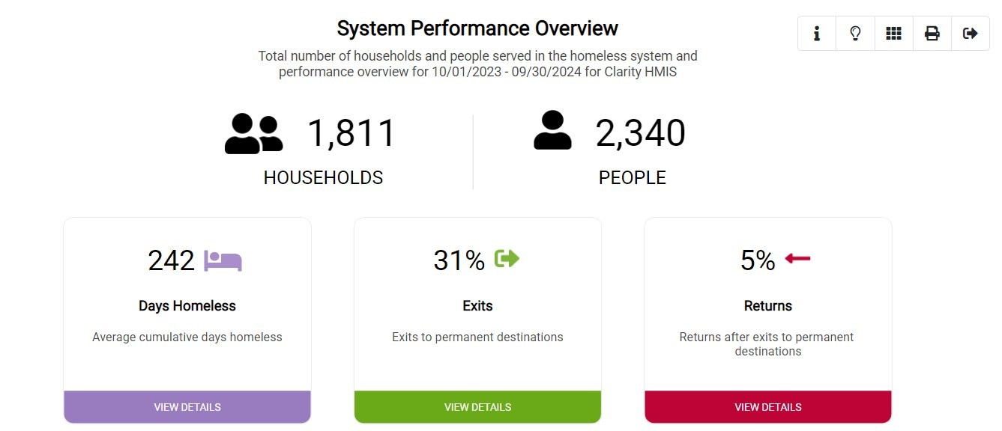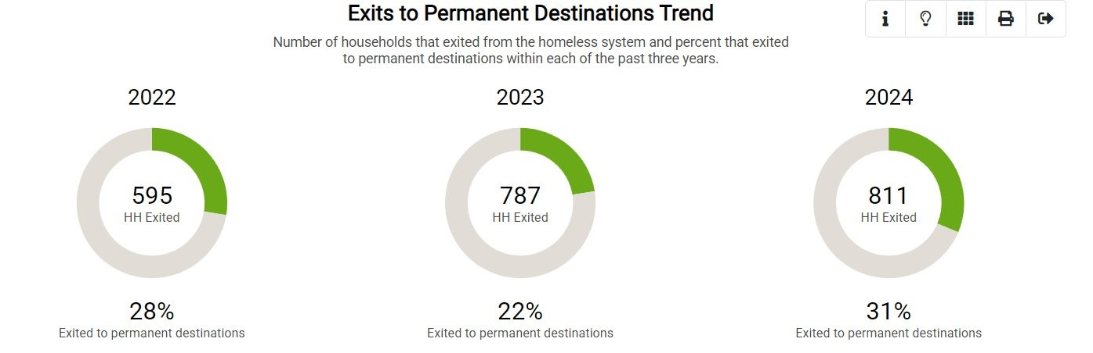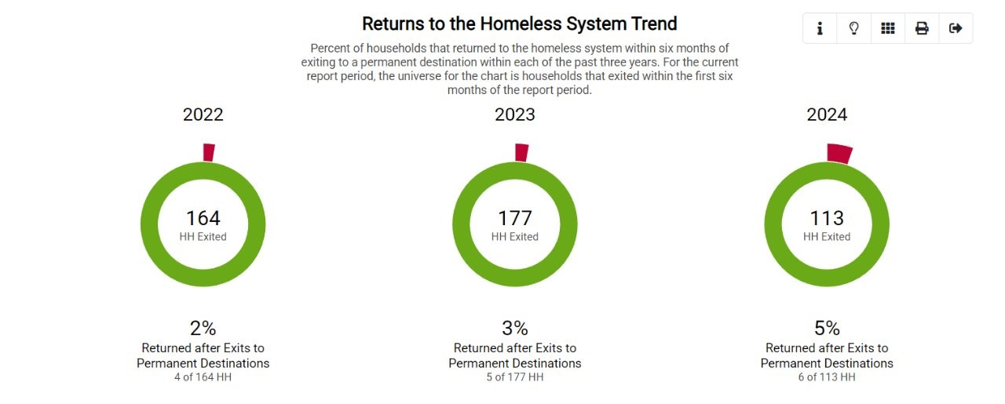

Committee Updates
All CoC committees and workgroups are looking for co-chairs and for people with lived experience of homelessness to lend their voices to the work of ending homelessness in the Three County area. The CoC staff have developed a policy that provides compensation to people with lived experience for their time and perspectives. Please note that the CoC Governance Charter states that “All Funded Projects must have representatives who participate on Committees. All Committees must include at least one Board member who is responsible for communicating committee activities to the Board.”

Coordinated Entry
The Coordinated Entry Committee reconvened on March 4th. In the meeting, the committee reassessed its goals, discussed a proposed new Coordinated Entry Agency Warm Hand off referral form, and an HMIS user agreement form. The committee will be working toward reevaluating the Coordinated Entry Vulnerability Assessment with the help of a TAC provider in the upcoming meetings. The committee discussed inviting new members, including more service providers that are actively completing the Coordinated Entry Assessment and more people with lived experience of homelessness.

The schedule for this meeting is set to occur on the first Tuesday of every month and will next meet on April 1st, 2025.

Data Evaluation Committee
The Data Evaluation Committee last met on March 10th. So far in 2025, the Committee has reviewed work done in 2024 and began early planning stages for the 2025 Gaps Analysis. The committee reviewed the results of the Longitudinal Systems Analysis (LSA) through Stella visualizations and the 2024 Gaps Analysis. With a larger membership in 2025, the committee has begun the process of creating a new survey or surveys for the upcoming gaps analysis to make recommendations for needed resources within Hampshire, Franklin, and Berkshire Counties.

In addition, the Committee is reviewing Coordinated Entry vulnerability assessment scoring recommendations to make to the Coordinated Entry Committee around the populations which should receive additional points on the vulnerability assessment for being overrepresented in the population experiencing homelessness compared to the general population in the local area. Suggestions include changes to how points are added for race and ethnicity—specifically, combining the fields and allowing additional points for every eligible race and ethnicity a person identifies with (instead of a “Yes” or “No” dichotomy for each). The other suggestion is to remove additional points based on a “gender” category altogether, because typically only men and transgender or non-binary persons are overrepresented in the population experiencing homelessness. Transgender persons would be added to the “LGBQ” category to include additional points for overrepresentation based on LGBTQ+ status rather than gender. Transgender persons would still receive additional points on the assessment but cisgender heterosexual men would not.

The next meeting is scheduled for April 14th from 11:30am – 1:00pm.

Domestic Violence (DV) Expansion
The DV Expansion Workgroup met on January 9th and will be meeting on March 18th.
Meetings in December and January were used to solicit feedback on the rollout and implementation of VAWA requirements for Subrecipients of the CoC. The workgroup provided feedback on what forms of documentation participants could provide to certify their need for an emergency transfer, and other features of Emergency Transfer Plans and Notice of Occupancy Rights that will be provided to all participants of CoC and YHDP funded projects.
Upcoming meetings will focus on updates to Homeless Verification forms for Category 4 of the Homeless Definition. This is in anticipation of the new DV Rapid Rehousing project by the Salasin Project, who hopes to take referrals soon.
The group is also reviewing its goals and hoping to work on a DV 201 training.
The next meeting is scheduled for Thursday April 10th from 2:00-3:30 PM

Community Success Committee (Previous Equity and Inclusion Committee)
The Equity and Inclusion Committee last met on March 12th. In January, the Committee identified what they wanted to focus on and accomplish in 2025. Focus areas include identifying what trainings the community wants, holding another resource/education/networking event, outreach and engagement to landlords, and continuing to develop connections between other agencies and the municipalities.

The February meeting was dedicated to developing survey questions to inform the CoC’s application for the National Alliance to End Homelessness Workforce Development Grant. The questions asked about if employer funded career advancement or physical/mental health opportunities would impact a decision to stay/leave; barriers getting to/completing work; potential uses for an employer emergency fund; if a $1.50 raise would impact a decision to stay/leave; and the impact of a sign-on bonus; and were included on the Climate Survey that all subrecipients were required to complete.

The next meeting is scheduled for March 19th.

People with Lived Experience (PLE) Action Board
The PLE Action Board last met on March 6th. In January, the PLE joined in the efforts of the PIT count, attending trainings, and being present at decision making tables. During this same meeting the group came up with a list of actions and goals that they would like to complete over the next year. Some of the mentioned items are, a “Homeless Utility Handbook”, doing another round of the Summer Cooling Kits, and working with the CoC to conduct a Summer PIT count. During the February meeting, the group heard updates from Natalie about how the PIT count went, had a guest attend from the Southshore CoC to see how this group works to gain some knowledge as they are in the process of creating their own PLE group, and also started to move their identified goals and actions into chronological order of how they want to complete things over the next year. During the March meeting the PLE committee welcomed the newly formed Southshore CoC PLE group to ask questions. The group addressed and created a TalentLMS Training Policy, geared towards understanding which trainings are accessible to PLE and which one are not, such as HMIS, CE and Subrecipient specific trainings. The group also continued organize in chronological order what they would like to achieve for the next year. The group was asked to participate in a focus group to assist Destination Home in Santa Clara County California to identify Leadership gaps.

The next meeting is scheduled for April 3rd.

Ranking and Evaluation Committee
The Ranking and Evaluation Committee last met on February 27th. During the February meeting the committee focused on Subrecipient Monitoring and Evaluation with a discussion on whether to implement subrecipient monitoring in 2025 and how it will be carried out in the coming months.
The group provided past monitoring reflections and feedback was gathered on last year's monitoring process, including a questionnaire sent to subrecipients and an Excel sheet used by COC staff for scoring. There was a review of the evaluation components including client file evaluation, compliance, fiscal pieces, and performance outcomes, and the mathematical process used for weighted scoring. The group also had a discussion on using the first year to support recipients and prepare them for a better evaluation in the second year. And gaps in guidance for subrecipient monitoring were identified, with plans to address these through monthly office hours and feedback sessions. The group reviewed compliance and policy updates, and a review of the subrecipient questionnaire was also completed.

The next meeting is TBA.

Reimagining Interim Housing Workgroup
The Reimagining Interim Housing Workgroup last met on February 14th. In the fall, the Workgroup finalized what, from the work done with the Iceberg Model, was most related to interim housing. Next steps are to begin creating an action plan. Attendance at the past few meetings has been low and so significant progress has not been made on the action plan.

The next meeting is scheduled for March 14th.

