Independent Housing Solutions, Inc.
5 Franklin St, Northampton, MA 01060
Fax (413)376-7176

Project Status Report

Project Summary

Report Date | Project Name | Prepared By
01/24/2023 | 5 Franklin St Renovation | Dr. Jessica Bossie

Status Summary

Project Completion Report: Building Renovation
Project Summary: The renovation project for the building located at 5 Franklin Street was 90% completed as of January 24, 2023. The project consisted of converting an existing office building into 16 affordable housing units, supported by multiple common spaces (kitchen, entertainment space, leisure areas, dining areas),as well as a medical office and case-working space. The project required updating the electrical and plumbing systems, installing a new fire sprinkler system, flooring, drop ceilings, windows and doors, and redesigning the interior layout. The exterior was improved by installing a new fence to provide privacy and safety to the residents.

Scope of Work:
- The office space was converted into affordable housing units, including the redesigning of new kitchen and bathroom fixtures, and redesigning the interior layout to optimize space and functionality.
- The affordable housing units were designed specifically to accommodate complex medical needs. All are ADA accessible and multiple have specialty features.
- Two such rooms are designed as a “master suite”, but with the doors eliminated. This design allows bariatric and paralyzed individuals access to a bathroom without navigating doorways and tight spaces.
- Electrical updates included installation of new wiring and lighting fixtures, as well as an upgrade to a smart home system.
- Plumbing updates included replacement of old pipes and fixtures, and the addition of a new water filtration system.
- New windows and doors were installed to improve energy efficiency and enhance the building's overall appearance.
- The interior layout was redesigned to optimize space and improve functionality. This included reconfiguring the floor plan, adding new walls and partitions, and updating the finishes and fixtures.
- The office space was converted into affordable housing units, including the redesigning of new kitchen and bathroom fixtures, and redesigning the interior layout to optimize space and functionality.
- This included the addition of new walls and partitions to create individual units, as well as the installation of new electrical, plumbing, and HVAC systems.
- Common areas, such as lobbies and corridors, were also updated to achieve complete ADA accessibility and create a welcoming environment for residents.
Timeline:
- The project began on April 1, 2022, and was almost completed as of January 24, 2023.
- The project was completed almost on schedule, with minor delays or disruptions due to supply and delivery issues.
- The remaining construction items -that do NOT prevent tenant move-in, are: completion of the landscaping (paving and planting that will occur in the spring) and installation of counters and cabinets in both the medical office and kitchen.
- During construction, our organization secured recurring HUD funding the in amount of $145,443 and hired two employees.
Costs:
- The CPA award for this project was a generous $608,000
- The total cost of the renovations, to date, is $661,000. This includes all materials, labor, and equipment expenses.
- The estimated cost at completion is $732,000.
- The project was completed slightly over budget, due to minor cost overruns and unexpected expenses.
- The shortfall has been manageable thanks to an generous earmark from Senator Jo Comerford in the amount of $128,500 and a generous gift from the Friends of the Hampshire County Homeless Individuals in the amount of $100,000

Quality Control:
- Quality control inspections were conducted throughout the project to ensure that all work was completed to the highest standards.
- Any issues or defects were identified and addressed promptly to ensure that the final product met or exceeded expectations.

Conclusion:
The renovation project for the building at 5 Franklin Street has been completed successfully, with slight delay, and little over the budget. The updated systems and redesigned interior layout will improve functionality and energy efficiency, while the new windows and doors will enhance the building's overall appearance. We are confident that the building will serve its occupants well for many years to come. The new SRO units will provide much-needed affordable housing options for the homeless population of our community, and the updated common areas will create a welcoming environment for residents. The building's energy efficiency has been improved and the exterior has been enhanced, making it a valuable addition to the community. We are proud to have been a part of this project that will have a positive impact on the community for years to come.
Photographs:

Photos from the start:
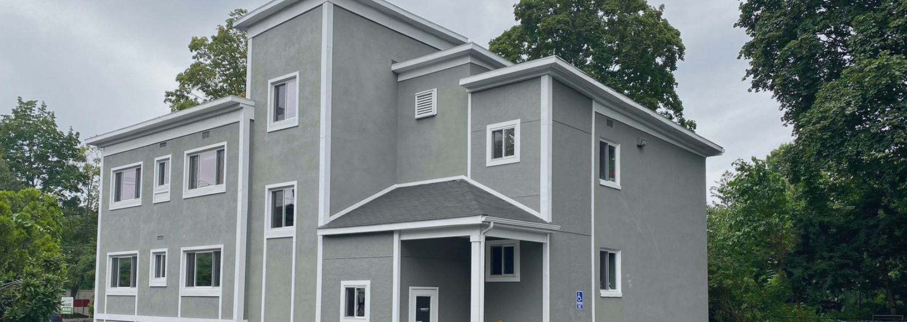

A Master Suit Midway Through Construction to Now:

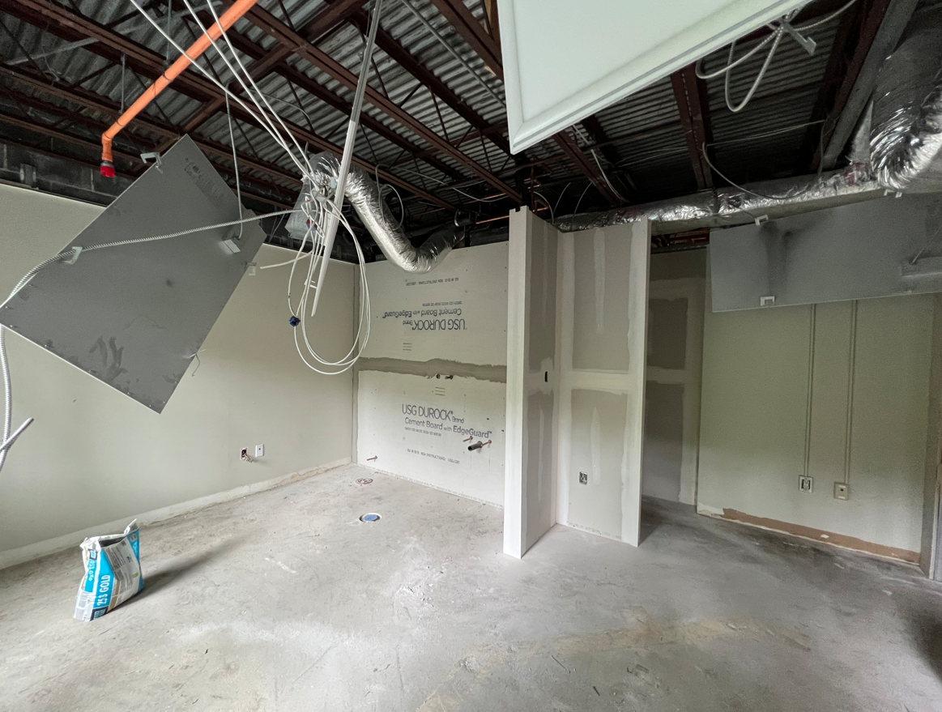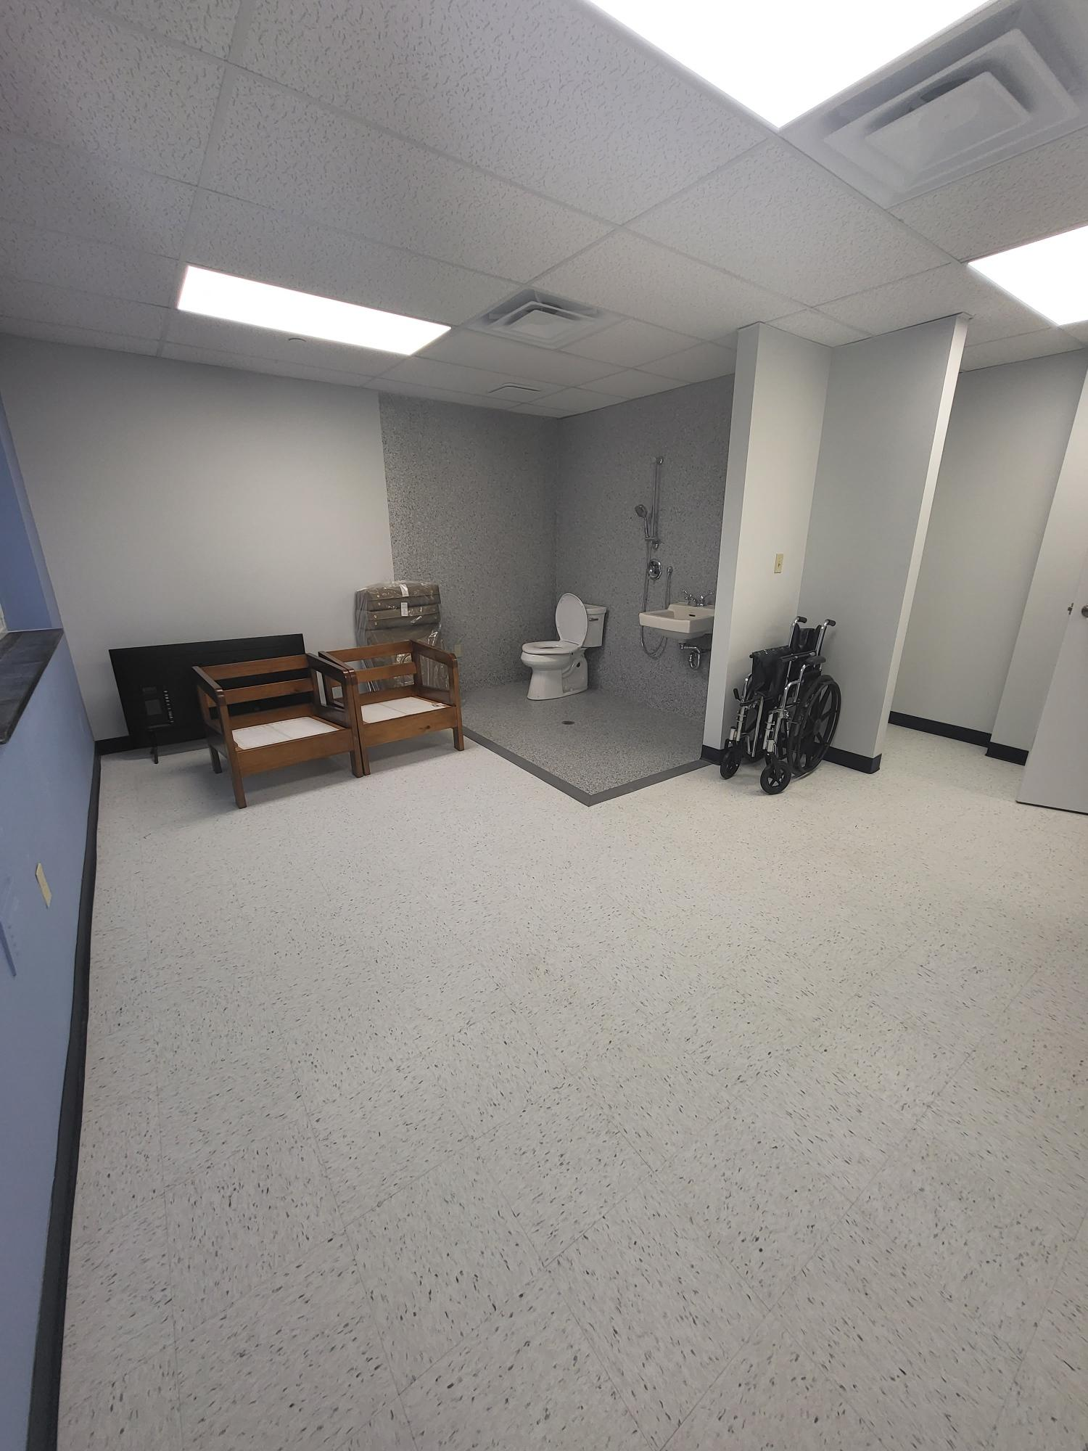

A Common Space from the Beginning to Now:
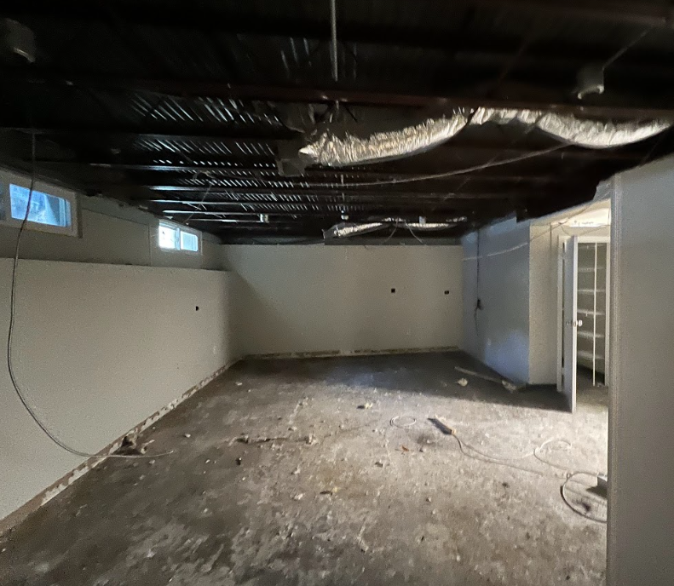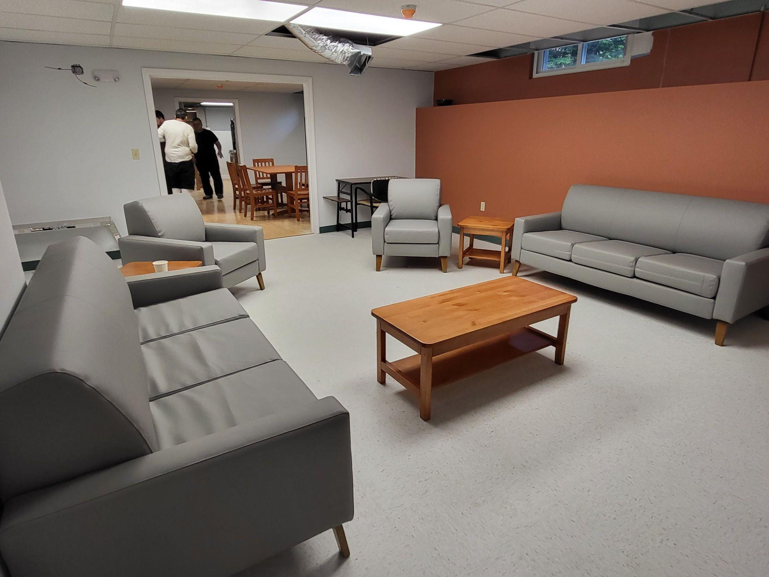

A Bedroom from the Beginning to Now
